CHAPTER 1

1. PROJECT BACKGROUND

Death Care Management refers to the management of funerary arrangements including care of the dead and services offered to surviving family. In the country, there are some notable high-profile funeral houses and parcel of what is now known as death care industry. These funeral houses-crematoriums are run like corporation, with life plans, packages, benefits, product development, services, and perhaps a dash of CSR (corporate social responsibility). The country’s leading death care companies include St. Peter Memorial Chapels, Loyola Memorial and Crematorium, Arlington, Nacional, Sanctuarium and La Funeraria Paz.

Administrative system refers to a network of organizations with specific rules and goals, structures, resources and programs. It includes the internal processes of and the interaction between and among public organizations, which are constituted to implement, help formulate, monitor or assess policies. Moreover, Administrative system is the process of creating information systems and supervising its flow from and to others within organization. Most job functions within a business involve performing some form of administrative management in or order to store and pass on information to use it in order to contribute to the business. Administrative System consists of four modules based on the project system, which describe the main process and the purpose of its functions. These are Legal Management, Document Management, Facilities Reservation and Visitors Management System.

Legal Management this is a professional and academic discipline derived from the incorporation of the study management into law it entails all activities associated with monitoring, supervising, controlling and directing the activities of law.

Document Management is the process of managing information through client to employee. This usually involves performing the Human Resources and distribution of information of employee to document. Document Management comprises all information, compiling the records for document.

Facilities Reservation refers to the process of managing schedules of the personnel’s reservation requests of the facility needed, which may be used for formal meetings, events and other purposes. It helps the company and its organization to utilize their facilities and other resources. It also provides efficient monitoring and usage of real estate facilities.

Visitor Management refers to the practice of welcoming, processing and monitoring guests at worksites, offices or other facilities. Visitor Management System refers to the tools used to perform this practice and range from basic, like logbooks to more advance software systems. At the most basic level, Visitor Management systems perform the important task of tracking who is on company premise.

1.1 Problem/Opportunity Description

The following are the problems and opportunity that was empirical and will motivate the proponents to create a better project system that will provide solution to the needs of clients, especially to the user and organizations that will use this project.

* Long time tracking of case records (Legal Management)

Having a manual process for legal management system can be hard for tracking important documents because of that they need to give some time for finding legal documents in unorganized cabinets.

* Poor Cross-Functional Collaboration (Document Management)

An organization that lacks an appropriate electronic content management platform risk falling into the trap of running multiple business-unit content management platforms for handling documents.

* Inefficient Reservation Management (Facilities Reservation)

Since some users sometimes overtime due to not obeying or not noticing the time duration, the manual system doesn’t have the capability to monitor duration of usage. This may cause trouble when there’s a subsequent user.

* Inaccurate and unverified information (Visitor Management)

Visitor filling out paper and pen record system can fake their true identity. Illegible information may occur especially when the visitor is not focused on which often results to unreadable information. Most of paper and pen record system are lacking in visitor information and details due to limited space of the paper. An electronic system that can digitally input information, capture photo and store scanned ID should be used.

* Time-consuming document tracking, case record tracking, facility reservation workflow and visitor sign-in process.

All the time traditional systems in tracking of document, case record finding, reservation of facility, and visitor sign-in process will take some time to do the task. These are a clear manifestation of slow process and less productive business entity.

1.2 Benefits

These are the benefits of having the proposed system:

* **Improve productivity**
* **Enhance data accuracy**
* **Improve data security**
* **User-friendly graphical user interface**
* **Improve data storage**
* **Control emergency response**
* The proposed system will benefit the sponsor, user, client, employee, Administrative Manager, Facility Manager, law practitioner, organization, future researchers for reference purposes and the project team.

1.3 Goals

The proponent’s main goal is to develop an Administrative System. Plan, analyze and implement methodologies or strategies to solve the problem encountered by the user from the existing system in order to meet the client satisfaction.

* 1. Stakeholders

Persons that are involve in the developing of the project system:

* Users

These are the one who will use the system.

* Death Care Company

The entity whose responsible in giving additional information needed in developing the proposed system.

* Administrative Manager and Facility Manager

These people are responsible for training the users how to use the system. These are the recipient of the reports for easy and timely decision making.

* IT Staff

These are the people who is responsible for technical support and sharing expertise in the developing of the project system.

* Future Researcher

The system will benefit the future researcher as a benchmark in their own project.

* Project Team

The proponents gain knowledge and keen motivation to adapt changes in the system.

2. Project Scope

The proponent will develop workflow defining the Administrative System. A system that focused in four areas such as follows:

* Legal Management System
* Facilities Reservation
* Document Management System
* Visitor Management System

The project will be developed by a team composed of competitive and skilled individuals through low-cost resources in terms of planning, analyzing, and implementing strategy and methodology that resolves problem of users from the existing project. The proposed system will be completed an estimate of around seven months.

2.1 Objectives

There are several main objectives for this project:

* To develop a system that will secure the information stored in it.
* To design a system that has easy to use features and personalized graphical user interface.
* To build a system that digitally and accurately input data
* To manage a system that will lessen or streamline the workflow and integrated with notification alerts.
* To create a system that can able to view available facilities, view list of documents, view list of today’s visitor, view present case files.
* To construct electronic system that will generate timely reports such as daily, monthly and annually.
  1. Deliverables
* Objective 1 – To develop a system that will secure the information stored in it.

|  |  |
| --- | --- |
| Project Deliverables | Description |
| Log in Form | Able to give a client an appropriate Log in Security. The system has its own unique security. |
| Log in Security | The system has validation notice before you proceed to the next step. |
| User’s Accessibility | Able to identify the user level and modify their own access to the system. To make sure that the user will be able to use a system properly. In order to give them a tight security. Assigned passwords will be applied with high level of encryption. |

*Table no. 1 To develop a system that will secure the information stored in it.*

* Objective 2 – To design a system that has easy to use features and personalized graphical user interface.

|  |  |
| --- | --- |
| Project Deliverables | Description |
| Personalized main panel | The system has simple main panel and user-friendly graphical user interface. |
| Multi-skinned panel | The system themes can be change in to several available colors. |

*Table no. 2 – To design a system that has easy to use features and personalized*

*graphical user interface.*

* Objective 3 – To build a system that digitally and accurately inputs data.

|  |  |
| --- | --- |
| Project Deliverables | Description |
| Input Forms | The user can easily input data at the system’s input fields. |
| Output | The system allows the user to view list of data inserted to the system. |

*Table no. 3 – To build a system that digitally and accurately inputs data.*

* Objective 4 – To manage a system that will lessen or streamline the workflow and integrated by notification alerts

|  |  |
| --- | --- |
| Project Deliverables | Description |
| Quick process of data | The user can easily save, update and delete the desire data. Also search for the necessary information. |
| Reduce transaction time | The user can use the system in a less transaction and process. |

*Table no. 4 To manage a system that will lessen or streamline the workflow*

* Objective 5 - To construct electronic system that will generate timely reports such as daily, monthly and annually.

|  |  |
| --- | --- |
| Project Deliverables | Description |
| Generate and print report. | The system can generate report periodically as well as print when necessary. |
| Viewing all transaction records | The system allows the administrator to access all the transactions and monitor log activity of user. |

*Table no. 5 To construct electronic system that will generate timely reports*

2.3 Out Scope

The following are some features that having a connection of a sub-system but not involve in this project scope:

Document Management System

* Document Tracking – Logistics
* Core Human Capital Management
* Human Resource Analytics
* Legal Management
* New Hire on Board

Legal Management System

* Document Management
* Compensation Planning and Administration
* Procurement Management

Facilities Reservation

* Training Management
* Learning Management
* Asset Management
* Chapels

Visitor Management System

* Facilities Reservation
* Core Human Capital Management
* Human Resource Analytics
* Customer Relationship Management

3. PROJECT PLAN

The proponents made a plan that required for the proposed system. We gather information and conduct research and interview in order to get an idea of what the system about. The phases of SDLC help to create the process of Administrative System.

3.1 Approach & Methodology

The proponents used Structured Analysis using System Development Life Cycle, conducted an interview for gathering information, analysis and observation. The proponents performed a system request, preliminary investigation report and as well as system planning. The team also gathers system specification, system design and development to implement the project execution of the system in an absolute way.

Planning Phase

Analysis Phase

System Maintenance

System Implementation

Design Phase

*Figure 1 Waterfall Model*

Project Planning

The proponents conducted an interview with Administrative Management of several death care company. Asking some questions regarding on the modules assigned, and after the interview the information gathered will be the data of the proposed system. The researchers gathered information inside the group through opinion and suggestion. To fully understand the process flow, the proponent also gathered information for those people with knowledge about the customer relationship management system.

Project Analysis

In this phase the proponents analyse all the data that gather, from the death care company and other resources to finalize all of information’s needed.

Project Design

In this Phase, design will be created using a HTML, CSS and Bootstrap Framework and web-based scripting language PHP with the use of Net Beans IDE, and also used high level architectural database and detailed design.

Project Implementation

After the design, in this phase the proponents used to code all of the transaction so that the system will have a function to have a workflow and to implement and deploy it to the client.

Project Support and Security Maintenance

After the developed system had been deployed to its main client, maintenance must be the necessary action, if ever there are any problems encountered by users.

3.2 Project Timeline

|  |  |  |  |  |
| --- | --- | --- | --- | --- |
| ID | Task | Start | Finish | Duration |
| 1 | Groupings and Distribution of Modules | August 14, 2017 | August 14, 2017 | 1 day |
| 2 | Draw lots of sub-modules | August 15, 2017 | August 15, 2017 | 1 day |
| 3 | Distribution of position | August 16, 2017 | August 16, 2017 | 1 day |
| 4 | The group conducted preliminary research about our modules and sub-modules. | August 17, 2017 | August 17, 2017 | 1 day |
| 5 | Processing of letter for interview from the IT Department. | August 18, 2017 | August 18, 2017 | 1 day |
| 6 | First attempt to conduct interview at the St. Peter Chapels Novaliches and Sta. Mesa. | August 19, 2017 | August 19, 2017 | 1 day |
| 7 | Second attempt to conduct interview at the St. Peter Chapels Sta. Mesa. Observed the process of visitor management system. | August 24, 2017 | August 21, 2017 | 1 day |
| 8 | Project Manager Meeting | August 28, 2017 | August 28, 2017 | 1 day |
| 9 | St. Peter Chaper Sta. Mesa granted an interview session. | August 31, 2017 | August 31, 2017 | 1 day |
| 10 | Drafting of Chapter 1 | September 4, 2017 | September 6, 2017 | 3 days |
| 11 | Submission of Chapter 1 | September 9, 2017 | September 9, 2017 | 1 day |
| 12 | Drafting of Chapter 2 | September 12, 2017 | September 14, 2017 | 3 days |
| 13 | Submission of Chapter 2 | September 16, 2017 | September 16, 2017 | 1 day |
| 14 | Designing of GUI | September 24, 2017 | September 29, 2017 | 6 days |
| 15 | Drafting of Chapter 3 and 4 | September 25, 2017 | September 29, 2017 | 5 days |
| 16 | Submission of Chapter 3 and 4 | October 7, 2017 | October 7, 2017 | 1 day |
| 17 | Review of database schema / finalize GUI | October 9, 2017 | October 9, 2017 | 1 day |
| 18 | Drafting of Chapter 5 | October 10, 2017 | October 10, 2017 | 1 day |
| 19 | Consolidation of databases | October 10, 2017 | October 10, 2017 | 1 day |
| 20 | Integration Attempt | October 13, 2017 | October 17, 2017 | 1 day |
| 21 | Final defense | October 14, 2017 | October 14, 2017 | 1 day |

*Table no. 6 Project Timeline*

3.3 Success Criteria

The proposed project considered successful when the following criteria was achieved:

* The system has a login form that has unique security features and not easily intrudes by unauthorized persons.
* The proposed system has personalized and user-friendly graphical user interface.
* The proposed system reduces workflow compared to existing system.
* The proposed system generates timely and accurate reports.
* The proposed system can view blacklisted visitor.
* The proposed system has the ability to adapt changes in terms of storage and future innovation.

3.4 Issues & Policy Implications

This part where the team has issues regarding the project system development.

* Compatibility of front-end and back-end software issues

The proposed system will not be integrated if there were conflicts in the version of the software and tools used in the development of the project. The proponents should use standard and same version of software or tools.

* Financial issues

Some of the group member is not 100% cooperative in terms of financial contribution.

* Time management issues

Conflict with schedules and lack of equipment to use in the project affects the project timeline and may lead to late delivery of the project output.

* Dependencies and individual work issues

Issues about the boundaries and connection to the other module's and subsystems.

3.5 Risk Management Plan

Legend: H-High M-Moderate L-Low

|  |  |  |  |
| --- | --- | --- | --- |
| Risk Factor | Probability | Impact | Risk Management Action |
| Financial Risk | H | H | Collection savings everyday |
| Technical Risk | M | M | Maintenance and technical support |
| Technological Risk | L | L | Compatible alternative Technology |
| Electricity Risk | M | L | Power saver batteries and save files every-time. |
| Natural Calamity Risk | H | H | Back-up all system activities and save the files immediately. |

*Table no. 7 Risk Management Plan*

3.6 Service Transition

These are the following process that the company will adhere to the software and hardware requirements, system specification, implementation procedure and maintenance for the system.

* Computers with required system specification to execute the system must be provided by the company.
* For the implementation of the system in the company, the proponents will provide quality training for the employees that will be designated as users.
* The proponents will execute plans, analyze and adapt changes upon problems encountered during transition period.
* The proponents will have a regular maintenance and updates for the system software.

3.7 Option Analysis

* Do nothing

The sponsor may opt to continue using the system because at the moment the business is doing well.

* Partial upgrade

The sponsor has the option to partially upgrade the system and request for specialized features that will integrate with the current system.

* Full modification

The sponsor has the option to fully modify the existing system and come up with a new project the may boost the business functions and processes.

4. Technical Features

|  |  |
| --- | --- |
| Software | |
| Name | Description |
| HTML5, CSS3, JavaScript Bootstrap 3 and PHP5 | This software is used in the front end of the proposed system. |
| MySQL Database with PHP MYAdmin | This software is used in the back end of the proposed system. |
| Windows 7 (Operating System) | This is the Operating System that the proponents used to create the whole document and system. |
| Adobe Photoshop CS6 | This is the software that the proponents used to edit some of the photos and some of the design of project. |

*Table no. 8 Technical Features (Software)*

|  |  |
| --- | --- |
| Hardware | |
| Name | Description |
| Hard Disk 500 GB | Device that stores all the software installed on the computer, as well as all the data files created and use by the software application. |
| Web Camera / external camera | Peripherals that captures digital photo. |
| Scanner | Peripherals that scan any document and store electronically. |
| Mouse | A device that control the movement of cursor or pointer on display screen. |
| Random access memory(RAM) 4 GB | Type of computer memory that can be access randomly. |

*Table no. 9 Technical Features (Hardware)*

1. PROJECT ORGANIZATIONS & STAFFING

|  |  |  |
| --- | --- | --- |
| Role | Names and contact information | Duties and responsibilities |
| Project Manager | Ronnie Mark S. Cabang  09567925095  [ronniemark.cabang@gmail.com](mailto:ronniemark.cabang@gmail.com) | * Overall in-charge in planning and execution of a project. * Responsible for all the processes in the creation of the project and guides team to reach the goal. |
| Business Analyst | Jonathan S. De Leon  09771388814  [recca_kobe8@yahoo.com](mailto:recca_kobe8@yahoo.com) | * Analyzes the business process. * Analyzes the workflow |
| System Analyst | Jonathan B. Magcamit  [magcamit_jonathan@yahoo.com](mailto:magcamit_jonathan@yahoo.com)  09068003867  Felix C.Samelo  09568738966  [samelo.felix@yahoo.com](mailto:samelo.felix@yahoo.com) | * Analyzes the system process or workflow. * Checking the system design. |
| Lead Programmer | Arvin E. Mendoza  09771907443  [Arvinmendoza57@yahoo.com](mailto:Arvinmendoza57@yahoo.com) | * Responsible for the creation of the project system’s physical design |
| Document Specialist | Cristian U. Allado  09503148528  cristian_kuletz@yahoo.com  John Christian D. Maac  09481894198  [jcmaac@gmail.com](mailto:jcmaac@gmail.com) | * Revise the copies of company forms. * Edit the documents for grammar, correct spelling and clarity. |

*Table no. 10 Project Organization and Staffing*

5. PROJECT BUDGET

|  |  |  |
| --- | --- | --- |
| Budget Item | Description | Cost |
| Internal Expenses | Print | 300.00 |
| GSM Internet Load | 500.00 |
| Tutorial Session (PHP Lesson) | 500.00 |
|  | PC Rentals | 500.00 |
|  | Laptop – 3 unit | 45,000.00 |
| MISCELLANEOUS | | 5,000.00 |
| Overall Cost: | | 51,800.00 |

*Table no. 11 Project Budget*

Chapter 2 Review of Related Studies

2.1 Local Studies

DOCUMENT MANAGEMENT

Archive One Document Management System Philippines

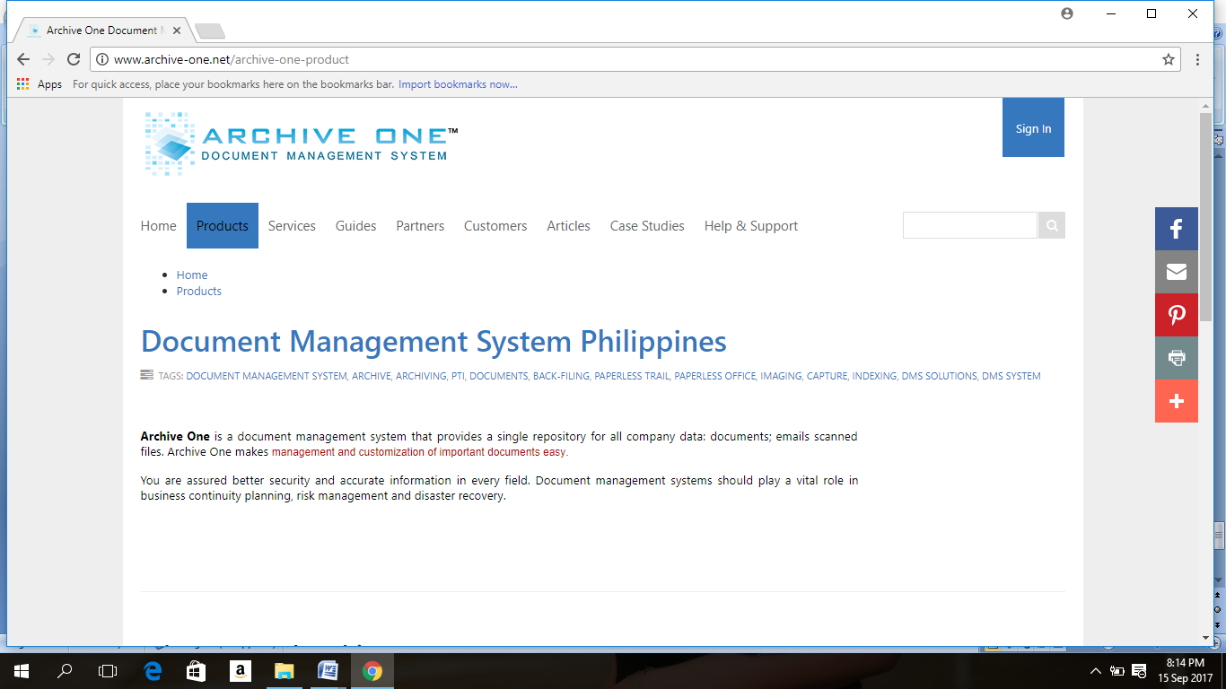

*Figure 2 Archive One Document Management System Philippines*

Archive One is a document management system that provides a single repository for all company data: documents; emails scanned files. Archive One makes management and customization of important documents easy.

You are assured better security and accurate information in every field. Document management systems should play a vital role in business continuity planning, risk management and disaster recovery.

Features:

Find Documents Fast   
With Archive One’s ability to create custom indices, it lets users find documents quicker and easier. The more keywords one creates, the more relevant documents will appear.

Secure documents access rights from viewing to checkouts  
Administrators can track users who have accessed the system and documents, allowing the company to monitor and secure any confidential information.

Ensure that documents are not tampered with manage document sets such as 201 files, regulatory documents, and related case files. Export the sets as merged PDF files with bookmarks or export to a folder. Store millions of records on terabyte storage .Archive One scales from a single server deployment to clustered environments with terabyte storage.

<http://www.archive-one.net/archive-one-product>

Paperless Trail Archive One

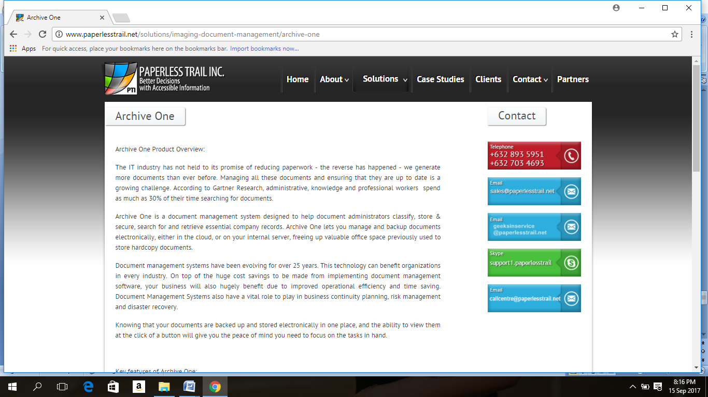

*Figure 3 Paperless Trail Archive One*

The IT industry has not held to its promise of reducing paperwork – the reverse has happened – we generate more documents than ever before. Managing all these documents and ensuring that they are up to date is a growing challenge. According to Gartner Research, administrative, knowledge and professional workers  spend as much as 30% of their time searching for documents.

Archive One is a document management system designed to help document administrators classify, store & secure, search for and retrieve essential company records. Archive One lets you manage and backup documents electronically, either in the cloud, or on your internal server, freeing up valuable office space previously used to store hardcopy documents.

Document management systems have been evolving for over 25 years. This technology can benefit organizations in every industry. On top of the huge cost savings to be made from implementing document management software, your business will also hugely benefit due to improved operational efficiency and time saving. Document Management Systems also have a vital role to play in business continuity planning, risk management and disaster recovery.

Knowing that your documents are backed up and stored electronically in one place, and the ability to view them at the click of a button will give you the peace of mind you need to focus on the tasks in hand.

 Key features of Archive One:

* Fast search & retrieval
* Check in/check out documents, bulk upload
* Version control for working documents
* User rights management and access control
* Comprehensive
* Document history logs (who accessed and viewed documents, which machine was used)
* File validity alerts for documents that need periodic review or renewal
* Document approval workflow
* Encryption of documents for enhanced security
* Document sets (with pre-defined document sets for SEC, BIR, HR)

Key benefits of Archive One:

* Efficient cost effective document management
* Space saving – reduction in document storage costs
* Improvement in compliance & risk management
* Secure remote access to documents
* Business continuity
* Collaboration and sharing

The smallest installation of Archive One has a single user and 80 thousand pages in the database, the largest stores more than 45million pages, and provides secure access to the documents to more than 1,000 users.

With all the benefits that come with Archive One, it is not a question of “can I afford to have a document management system” but whether you can afford not to have one.

<http://www.paperlesstrail.net/solutions/imaging-document-management/archive-one>

LEGAL MANAGEMENT SYSTEM

IBM Philippine Legal Management System

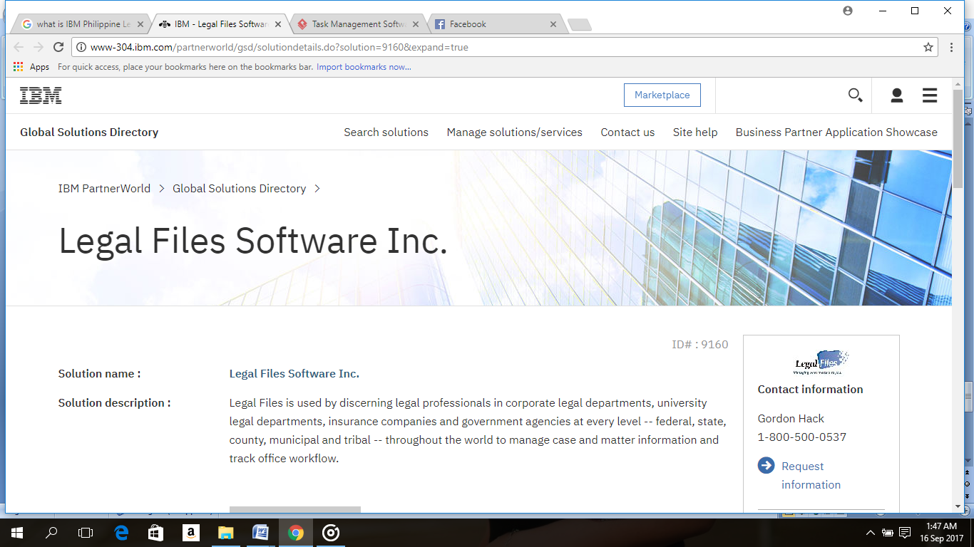

*Figure 4 IBM Philippine Legal Management System*

Legal Files is used by discerning legal professionals in corporate legal departments, university legal departments, insurance companies and government agencies at every level – federal, state, county, municipal and tribal – throughout the world to manage case and matter information and track office workflow.

Legal Files makes it easy to manage what matters to you. Our full-featured case/matter management software lets you organize your contacts, documents, contracts, deadlines and data within a proven, flexible set of windows and workflows that can be easily customized to your office. We offer exclusive, seamless two-way integrations with Microsoft Outlook, Lotus Notes and Novell GroupWise, so you can save all your file related e-mails, calendars and tasks in one place, sharing this information with others. Plus, we link to a host of other industry-standard legal applications. Most importantly, we provide superior training and expert support to get you up and running quickly and smoothly.

Features Checklist

* Calendar management
* Case notes
* Docket management
* Reminders
* Conflict management

<http://www-304.ibm.com/partnerworld/gsd/solutiondetails.do?solution=9160&expand=true>

Case Master Pro

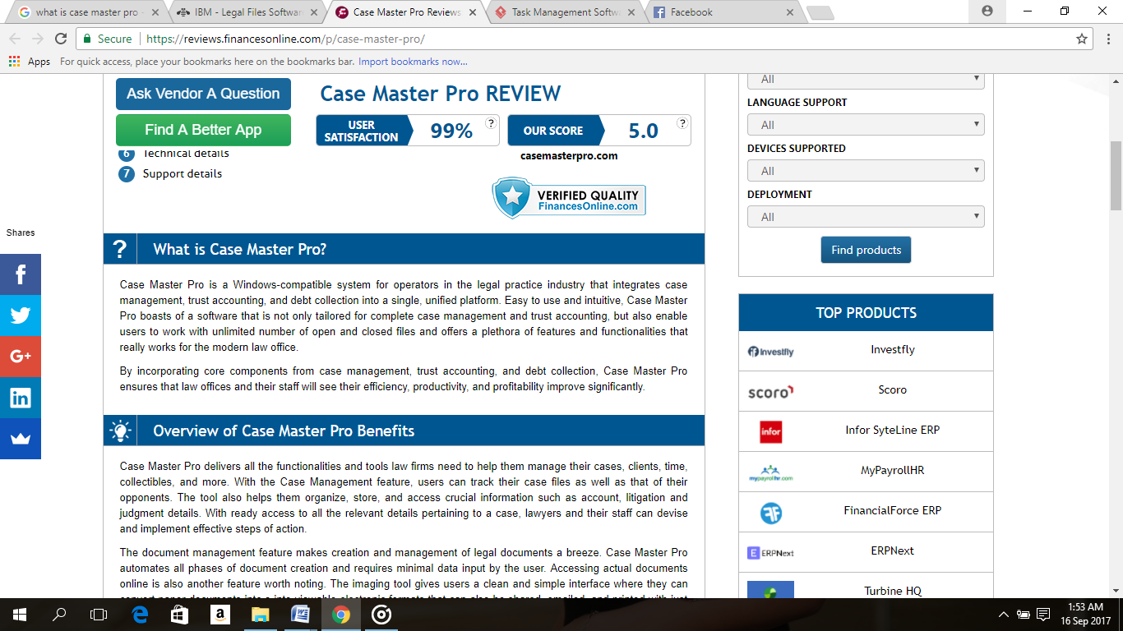

*Figure 5 Case Master Pro*

Case Master Pro is a Windows-compatible system for operators in the legal practice industry that integrates case management, trust accounting, and debt collection into a single, unified platform. Easy to use and intuitive, Case Master Pro boasts of a software that is not only tailored for complete case management and trust accounting, but also enable users to work with unlimited number of open and closed files and offers a plethora of features and functionalities that really works for the modern law office.

By incorporating core components from case management, trust accounting, and debt collection, Case Master Pro ensures that law offices and their staff will see their efficiency, productivity, and profitability improve significantly.

Features Checklist

* Calendar management
* Case notes
* Court management
* Conflict management
* Law Firms
* Docket management
* Discovery management
* Reminders

<https://reviews.financesonline.com/p/case-master-pro/>

FACILITIES RESERVATION

Skedda (Melbourne Australia)

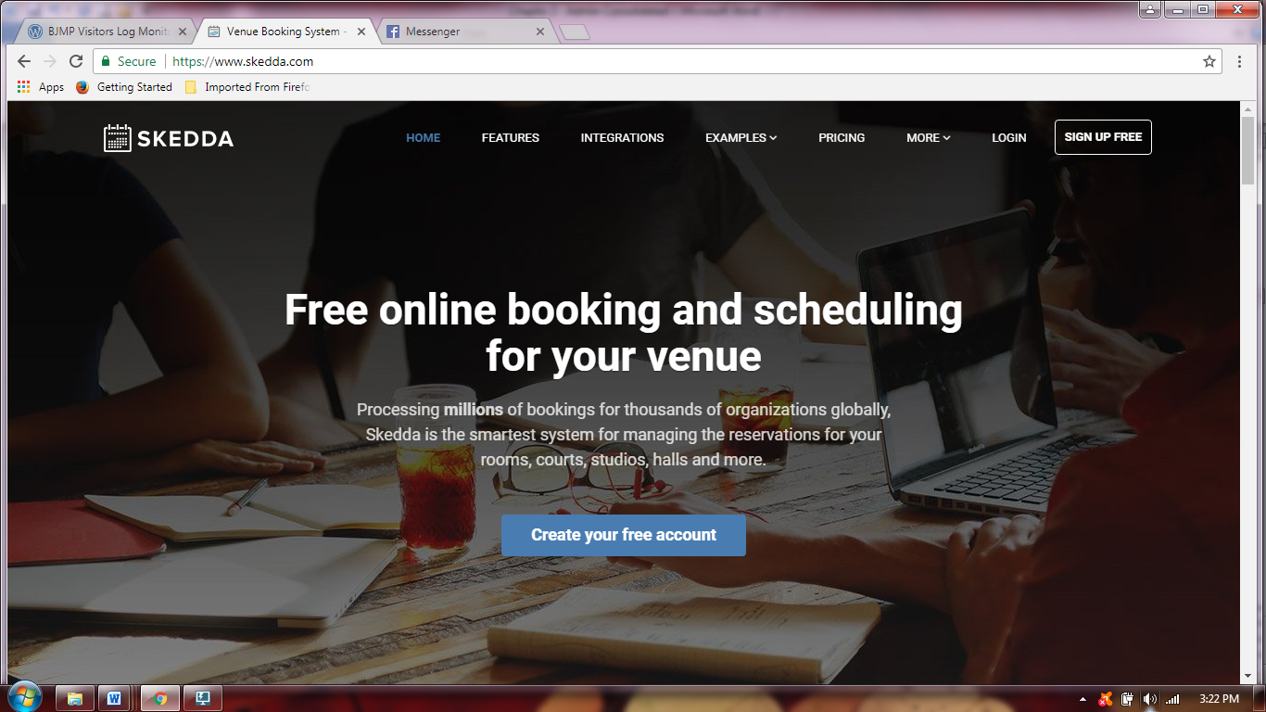

*Figure 6 Skedda (Melbourne Australia)*

Skedda was born from the need to “scratch our own itch”, but quickly turned into the flexible and powerful platform trusted worldwide by thousands of venues today.More specifically, back in 2012 they were involved in the management of a large sporting facility in Melbourne, Australia. They needed a way to manage bookings and payments for the use of the venue’s resources. At the time there was no shortage of existing products under the banner of “online bookings”, but none that truly nailed the elements that were important to them.These elements, which continue to be their obsession today, are: focus on the reservation of space-style resources (meeting rooms, courts, studios, halls), focus on collaboration and self-service so that venue users have the power to manage their own bookings (giving venue managers more time), an optimized approach that eliminates friction at every stage of product use, and first-class support (even for our customers on the no-cost plan).

Skedda’s Facility Reservation includes Booking Calendar, where Skedda gives you a visual of what is happening in your space and the simple controls to manage bookings on a daily basis. Online Booking where Skedda allows you to reduce administration by letting your users make bookings for themselves in only a few clicks. Fully Customizable, Skedda lets you to set things up to reflect the way your venue works, with first-class support along the way. User Management where Skedda makes it possible to manage your venue users in a clear and organized manner, allowing them to interact with the system in the appropriate way. Online payments where Skedda gives you the means to easily and securely accept payments during the self-serve booking process and Lastly, Mobile Friendly, Skedda plays nice with all mobile devices and lets you offer your users the perfect on-the-go booking experience. Skedda is also Provides notifications via SMS and Emails.

<https://www.skedda.com/>

ActiveNet (Dallas, Texas)

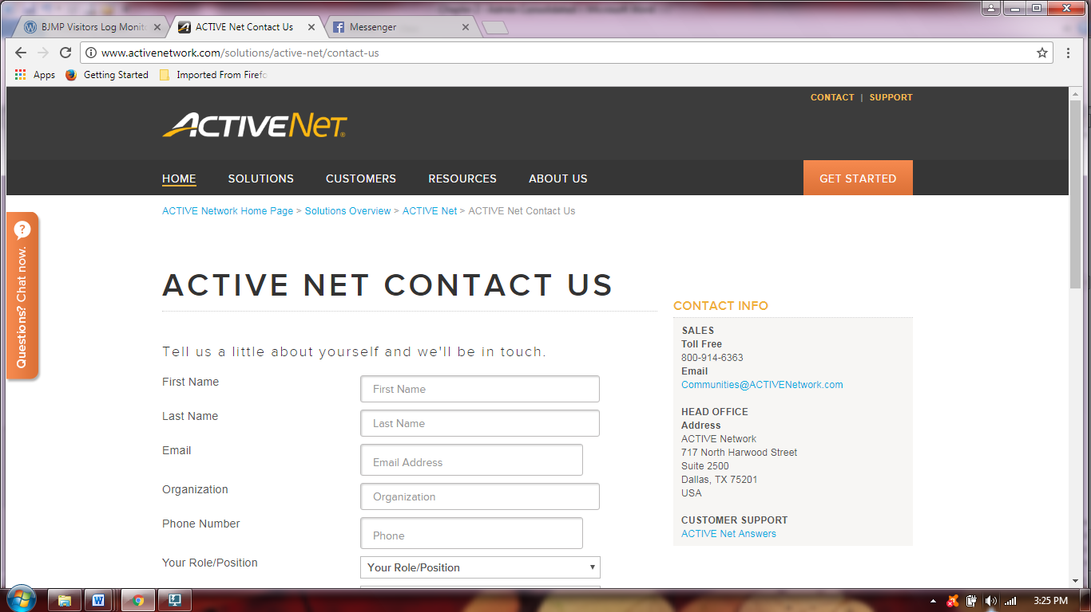

*Figure 7 ActiveNet (Dallas, Texas)*

Booking facilities doesn’t have to be a complex process with ACTIVE Net. Eliminate double bookings and make the reservation process easier for your staff and your customers with features like quick reservation, online facility maps and automated workflows. Managing facility reservations through one master book at the front desk can be risky. Only one ‘user’ can access the book at any time, payments sit in a different place, and double bookings occur. With facility scheduling software, you can simplify the process and save time with these features: Quick Reserve – Set defaults for your most common facility reservations and save up to five steps over regular reservations by setting pre-defined options. Scheduling Calendar – View multiple facilities at once by day, week or month in order to get a complete view of your calendar. Set global skip days and holidays to prevent reservation bookings on days your facilities are closed.Workflow Management – Automate the process of getting permits approved by management or another department. Use the stages feature to create workflows and ensure that approvers receive an email to approve reservation bookings. Facility Charge Matrix – Automatically configure charges for permits and different facility types rather than entering manually.Deposits and Claims – Protect against damages and cancellations by requiring deposits that can be automatically refunded after use. Another option offers flexibility by setting up claim charges to hold a facility before the full payment is due.

<http://www.activenetwork.com/solutions/active-net/facility-scheduling-software>

VISITOR MANAGEMENT SYSTEM

E.VIS Visitor Management System

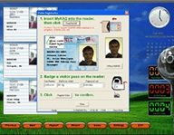

***Figure 8*** *E.VIS Visitor Management System*

E.VIS is an user-friendly visitor management system, it enhances corporate security through the identification of unwanted or suspicious visitors with the help of the MyKAD technology. E.VIS is designed to keep track of visitor traffic details. It also enables instantaneous background checks to be done easily. It minimizes processing time and generates visitor badges in seconds. The E.VIS incorporates a touch screen monitor, MyKAD reader, web-camera and proximity reader (EM, HID or Mifare) to provide the user with a simple and total solution for visitor management.

Features:

* Automatic log-in of visitor information within seconds through the MyKAD reader.
* Incorporated with a web-camera to capture a visitor’s image and business card
* Visitor card can be assigned within seconds
* Control visitor’s accessibility through an assigned visitor card
* Real-time visitor information
* Provides comprehensive reports

<http://elid.com.ph/index.php/products/visitor-management-system/77-elid/114-evis.htm>

ePLDT EVE – Enhanced Visitor Experience

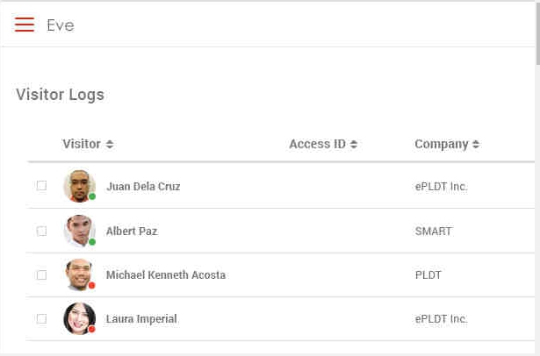

*Figure 9 ePLDT EVE – Enhanced Visitor Experience*

Companies that receive many guests face the challenge of monitoring and tracking the people going in and out of their premises. This can be inconvenient to receptionists, employees, and even to visitors especially when traditional recording is used.

ePLDT, Inc., with its continuing initiative to deliver best-in-class digital business solutions, launched its Enhanced Visitor Experience (EVE) app, a fully digital and interactive visitor registration system designed to help companies process incoming and outgoing traffic.

Features:

* Digital interface (visitor registration/pre-registration via a tablet & app) – Guest
* Web dashboard (via Tablet/Desktop) – Receptionist
* Push Email & SMS Notifications – Host
* Manage per location

<http://www.epldt.com/solutions/digital-engagement/eve/>

2.2 Foreign Studies

DOCUMENT MANAGEMENT SYSTEM

HyperSoft: Automated Hypertext Support for Software Maintenance

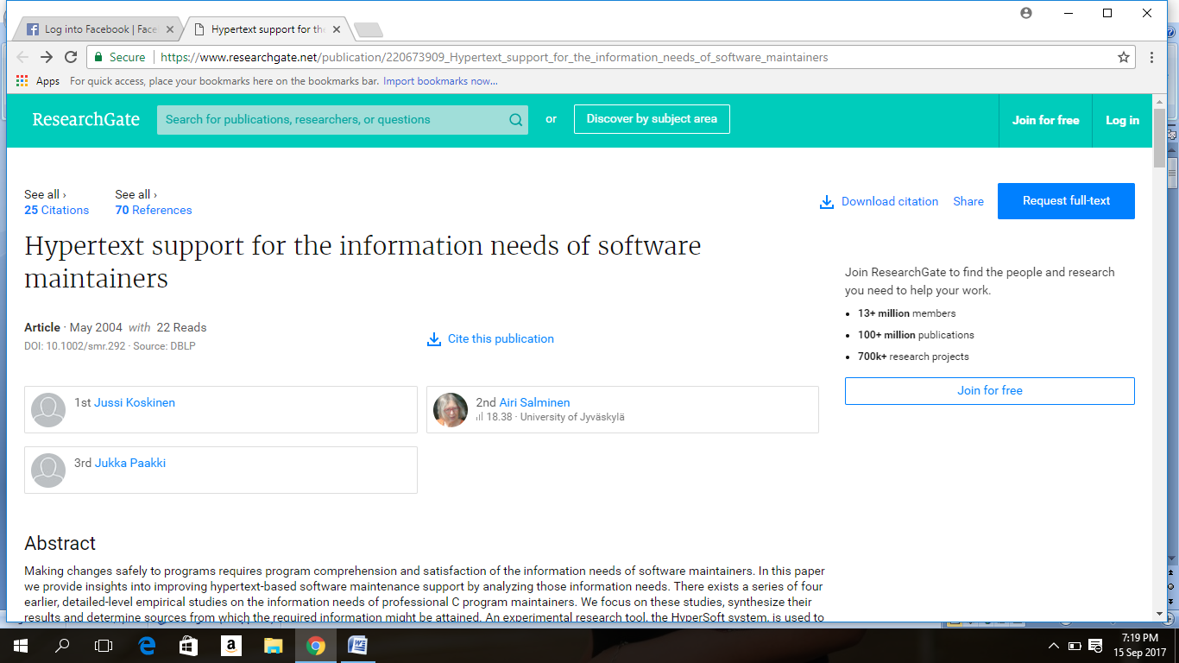

*Figure 10 HyperSoft: Automated Hypertext Support for Software Maintenance*

The project has developed a method and environment to support program reading, comprehension, and maintenance. In the method, a hypertextual access structure is generated automatically for a specific maintenance task and information requests. The HyperSoft system extracts structural and dependency information from source programs and shows the information to the user in hypertext form. The current HyperSoft system implementation is an experimental tool for ANSI-C program reading and maintenance. The programs may contain embedded SQL blocks.

The project is a joint project of the Universities of Jyväskylä and Helsinki, and it has been supported by TEKES, KT-Tietokeskus, Nokia, TT-Kuntapalvelut, and TT-Valtionpalvelut.

URL: <https://www.researchgate.net/publication/220673909_Hypertext_support_for_the_information_needs_of_software_maintainers>

Kofax Perceptive Document Management

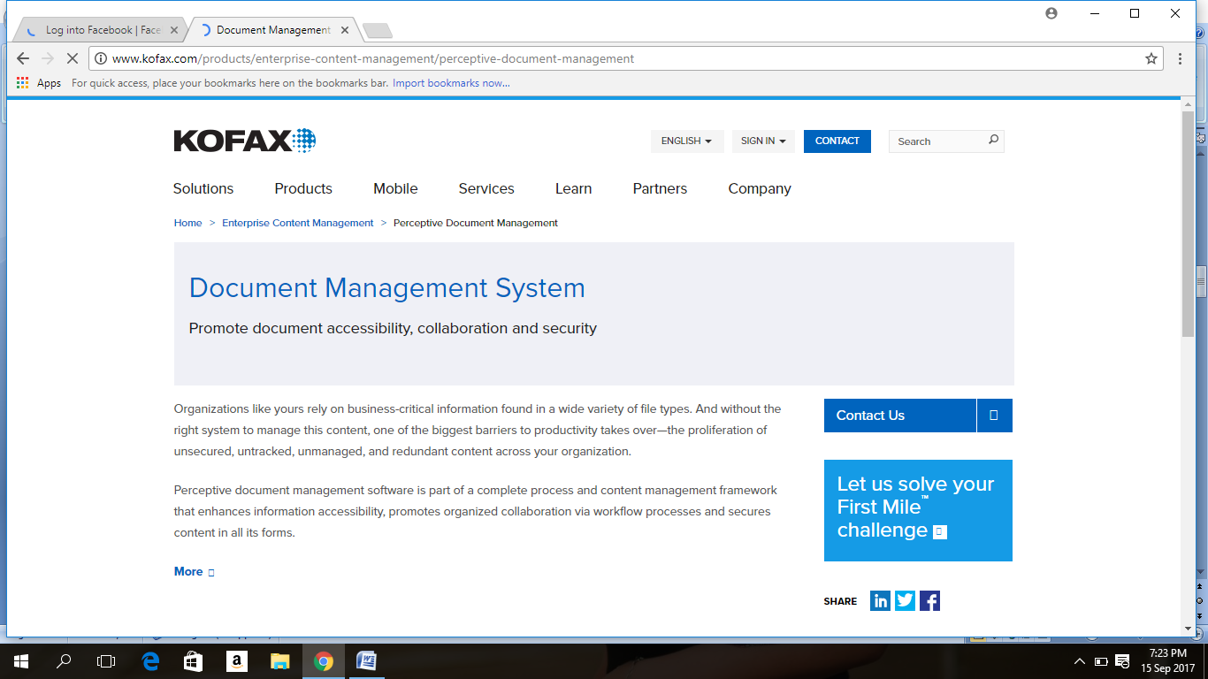

*Figure 11 Kofax Perceptive Document Management*

Organizations like yours rely on business-critical information found in a wide variety of file types. And without the right system to manage this content, one of the biggest barriers to productivity takes over—the proliferation of unsecured, untracked, unmanaged, and redundant content across your organization.

Perceptive document management software is part of a complete process and content management framework that enhances information accessibility, promotes organized collaboration via workflow processes and secures content in all its forms.

Document management from capture to disposition

Document management features start by eliminating one of the biggest barriers to greater productivity—unmanaged content creation. Our capture products put content under control from the moment it’s created or captured.

Granular security

A secure, central repository is the backbone of our electronic document management system, Perceptive Content, which is built around a security model that is engineered to let you:

Grant and revoke individual and group rights to each distinct system function

Restrict documents and document types based on a user’s point of access

Conceal confidential data while preserving a document’s original integrity

Organize all enterprise information in a secure, central electronic repository

Flexible organization

Effective document management systems require the proper classification or indexing of captured information.

Our integrated Content Models are built on industry requirements and best practices to help you capture, secure, process and locate content. It also lets you structure, manage and preserve content to best fit your business needs.

Configured in combination with standard technologies such as LearnMode™ and Pretrieve™, as well as Web services-based integration technologies, Content Models provide an essential tool for rapidly associating unstructured information with records in your core business systems.

Search

Our document management software includes flexible saved, ad hoc and integrated search options.

Access managed documents instantly within the context of a predefined process

Locate specific documents using system-assigned values or manually entered metadata

Perform full-text searches across large repositories

Effectively analyze, extract and manage metadata to make videos and other forms of rich media easily findable

Locate relevant content before you even ask for it with our exclusive Pretrieve feature

Library services

As users across an organization create, edit and maintain documents using any desktop application, they can easily apply version control and library services directly from a variety of interfaces, including Interact applications and Web services clients. It’s all made possible through the Document Control Suite.

<http://www.kofax.com/products/enterprise-content-management/perceptive-document-management>

LEGAL MANAGEMENT SYSTEM

ClioCloud

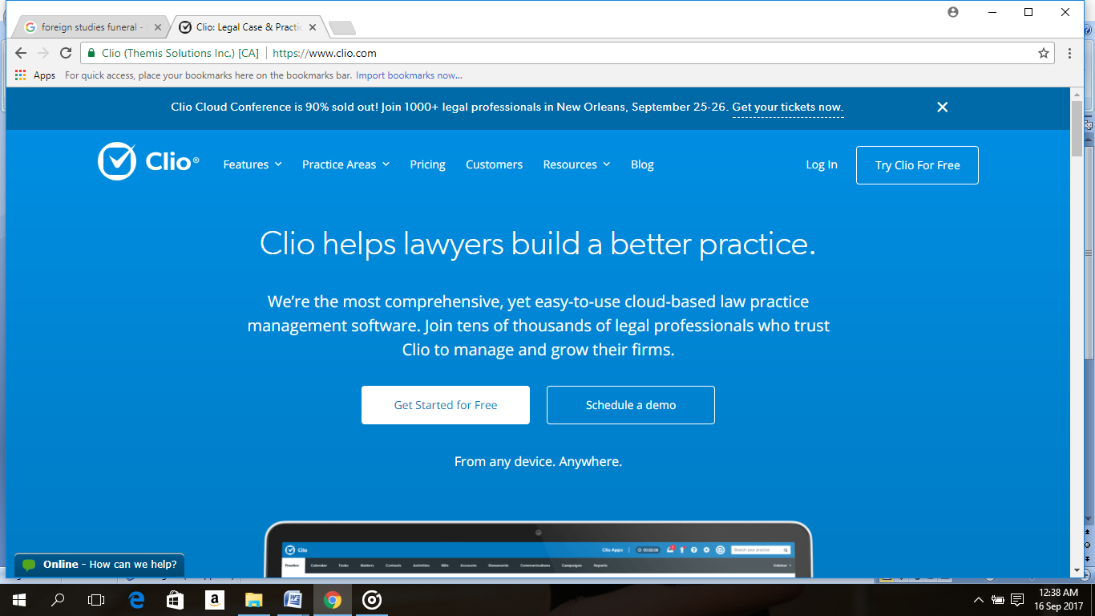

*Figure 12 ClioCloud*

Clio is the world’s leading cloud-based legal practice management software. Clio is an invaluable tool for law firms of all sizes. From basic features such as matter and document management, time tracking, and billing, to helpful enhancements such as credit card processing, marketing analysis, and over 50 integration partners, Clio has everything you need to optimize your firm.

Features Checklist

* Calendar Management
* Case notes
* Court management
* Law Firms
* Reminders
* Records management
* Task management

<https://www.clio.com/>

CaseFox.com

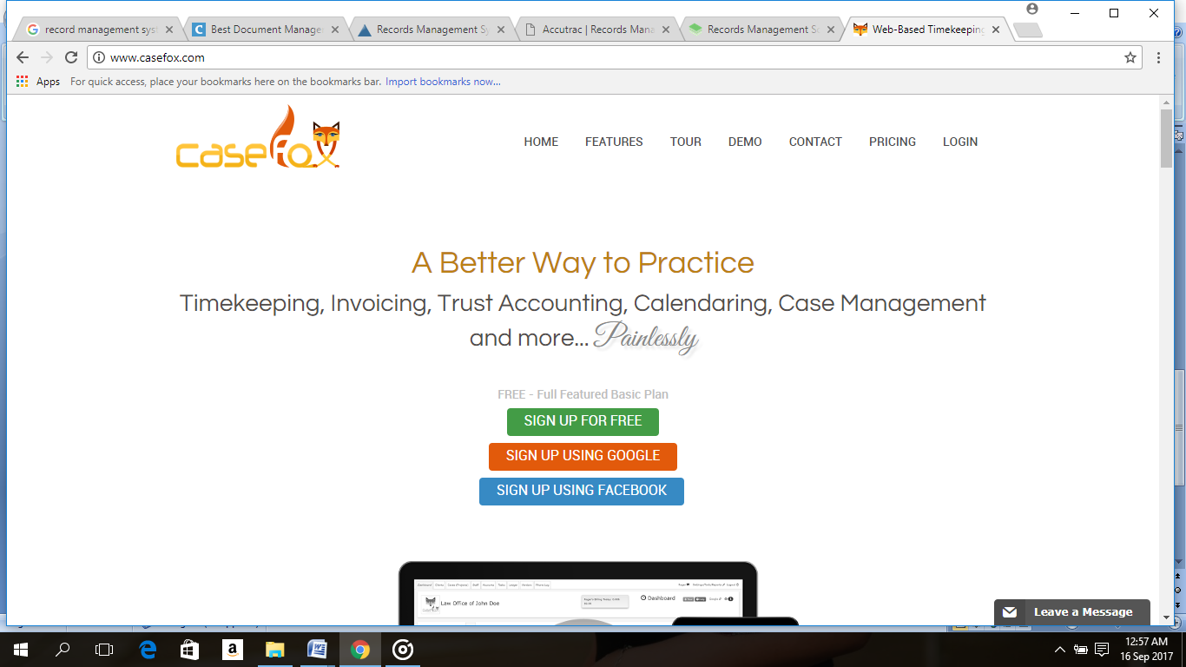

*Figure 13 CaseFox.com*

CaseFox.com offers a cloud based easy to use multi-user software that is designed for attorneys, CPAs and other professional with their practice management, billing, invoicing, trust fund management , case document management, client management, tracking billable time, expenses, payments etc.

Features Checklist

* Case notes
* Calendar management
* Court management
* Docket management

<http://www.casefox.com/>

FACILITY RESERVATION

Diamond Hotel Philippines

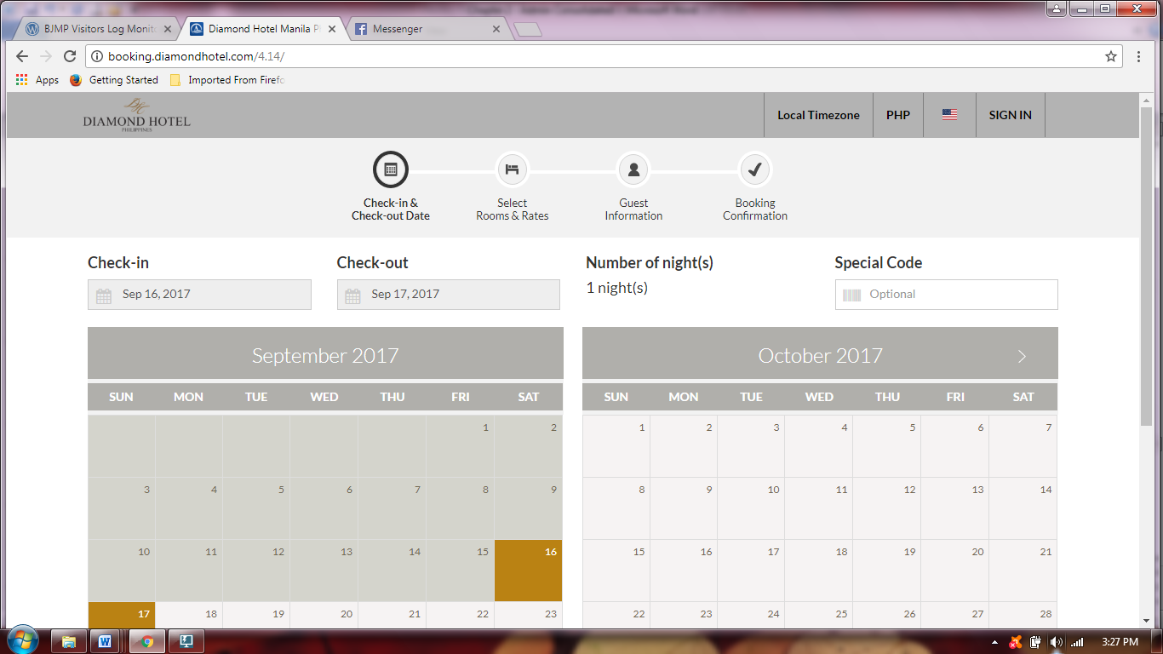

*Figure 14 Diamond Hotel Philippines*

Diamond Hotel has a variety of restaurants and bars specializing in different cuisines, offering guests a delightful experience. Luxurious function rooms are available for corporate events, meetings, weddings and parties. The Health Club and Spa, swimming pool, outdoor whirlpool, tennis court, LifeSpan Reflexology, and gym are all perfect for a holiday filled with recreational and fitness activities. Guests are guaranteed a wonderful experience of comfort, luxury and impeccable service at Diamond Hotel. Stay and experience the renowned Diamond Service by the hotel’s gracious associates.

The Reservation or Booking System of Diamond Hotel may be accessed online. The customers are required to follow the steps for reservation. The system first accept the Time-in and Time-out Time, Date and Preferential code is a computer-generated code, consisting of letters or numbers which may be used for discounts. The customers are required to select the facility or room they want to reserve, all the information about the facility are displayed. The system also needs the guest’s information such as number of people, since each rooms has their capacity.

(URL: <http://booking.diamondhotel.com/4.14/> )

Aim Conference Center (Makati)

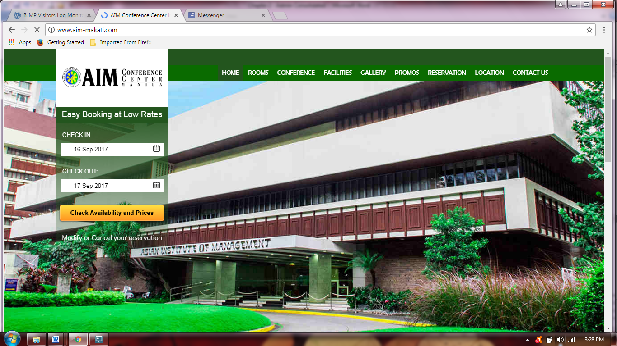

*Figure 15 Aim Conference Center (Makati)*

As the flagship of Asian Institute of Management’s prime conference venues, AIM Conference Center Manila (ACCM) is the top choice among event participants and travelers in Makati City, Philippines.

Managed by a team of seasoned conference experts, the institution makes sure that requirements are always met and the service approach creatively executed. Here, guests are surrounded with state-of-the-art facilities that ensure the success of any business endeavor held within ACCM’s premises. And with its line-up of executive Makati accommodations, spacious and well-equipped meeting rooms, on-site recreational amenities, exceptional F&B services, and flexible rates and packages, every need of today’s discerning corporate or leisure traveler is satisfied.

The prime accommodation and conference center is located inside the campus of the Asian Institute of Management (AIM), one of the finest graduate schools in Asia. It is strategically situated at the heart of the Makati Central Business District, a mere 5-minute walk from the city’s major shopping centers, embassies, banks, airline offices, and multinational companies.

The client may reserve their facilities online, the system accepts the arrival and departure dates, information about the facilities, they also have a free breakfast on some facilities as market strategy. The system requests the guest detail and the client may pay online via credit cards.

(URL: <http://www.aim-makati.com> )

VISITOR MANAGEMENT SYSTEM

Jolly Tech Visitors Management System

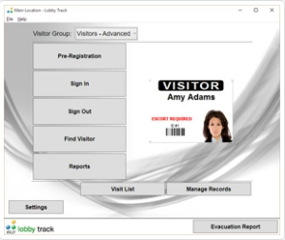

*Figure 16 Jolly Tech Visitors Management System*

Your business performs sensitive, delicate work. It’s important to maintain safety and integrity in the workplace, and one of the best ways to do this is to keep track of who is in your facility. Visitor management software is a step from the classic pen and paper logbook, and makes this job much simpler.

Integrating Lobby Track visitor management software into your existing processes and procedures is a snap. With Jolly’s flexible configuration the software adapts to your needs. Connect directly to most ODBC-compliant databases or start with one of our built in sample databases to get you up and running quickly. Using standard protocols and customizable options Lobby Track can conform to most of your company’s existing IT policies and procedures regarding backup, access restrictions and privacy.

Lobby Track, created by Jolly Technologies, is the premier solution to all of your company’s visitor management needs. Lobby Track makes it speedy and simple to check people in and out, reducing the complexity of the situation to nothing more than a few mouse-clicks. Lookup host information via your existing Active Directory system, auto email hosts, create badges generated from scanning driver’s licenses, and, If needed, even activate badges into your existing access control system. ID Flow, included with Lobby Track, makes design and formatting a snap.

In today’s world safety and security are of utmost importance, but modern security issues are far beyond simply locks and guards. It’s important to know who is coming in and going out, it’s essential to identify not only your staff, but visitors, contractors, maintenance workers, basically everyone that walks through the door. This may seem to be a daunting task, but you can make it fast and easy by selecting Lobby Track visitor management software for all your visitor management needs.

Features:

* Pre-Register Visitors
* Schedule visits in advance.
* Fast Sign In
* Electronically capture information and sign in.
* Print Visitor Badges – Issue professional, scan able visitor badges.
* Enhanced Security
* Check Watch Lists
* Check visitors against local and online watch lists
* Notify the host when a visitor arrives via e-mail, SMS or phone.
* Control Entry
* Enable and disable cards in access control systems.

<http://www.jollytech.com/software-and-systems/visitor-management-software.php>

AC2000 WEB Visitor Management

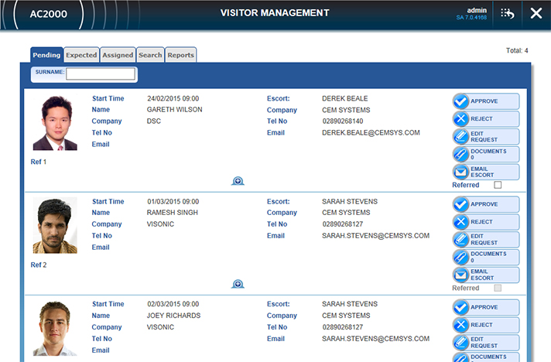

*Figure 17 AC2000 WEB Visitor Management*

AC2000 WEB Visitor Management is a powerful tool that enables users to request and manage temporary cardholders (visitors) from any location via a standard web browser. With an easy to use front-end web application, users can simply add visitor details, photos, sponsor details, reason for visit, visit duration and access level required.

Features:

* Remotely manage visitor access control via a standard web browser
* Cost effective way for multiple users within a facility to manage visitors without having dedicated access control software installed
* Record visitor details, reason for visit and staff sponsor details
* Automatic email notification to both visitor and selected visitor sponsor
* Full ID card printing capability
* Trace facility for visitor cards
* Allocate visitor time permissions & access levels as well as visit duration
* Reuse visitor cards
* Full history of visits stored for reporting – replaces need for manual paper-based visitors log
* Secure web page data transfer utilizing Hyper Text Transfer Protocol with Secure Sockets Layer (HTTPS)

2.3 Matrix

DOCUMENT MANAGEMENT

|  |  |  |  |  |  |  |  |  |  |  |  |
| --- | --- | --- | --- | --- | --- | --- | --- | --- | --- | --- | --- |
| Document  Management  Features | Local Studies | | | | | Foreign Studies | | | | | Proposed System |
| Hypertext | kofax |  |  |  | Archive One | Paperless Trail |  |  |  |
| Log in | ✓ | ✓ |  |  |  | ✓ | ✓ |  |  |  | ✓ |
| Dashboard | ✓ | ✓ |  |  |  | ✓ | ✓ |  |  |  | ✓ |
| User Friendly | ✓ | ✓ |  |  |  | ✓ | ✓ |  |  |  | ✓ |
| Access Permission | ✓ | ✓ |  |  |  | ✓ | ✓ |  |  |  | ✓ |
| Analytical Report | ✓ | ✓ |  |  |  | ✓ | ✓ |  |  |  | ✓ |
| Log in | ✓ | ✓ |  |  |  | ✓ | ✓ |  |  |  | ✓ |
| Dashboard | ✓ | ✓ |  |  |  | ✓ | ✓ |  |  |  | ✓ |

*Table 12 Document Management Matrix*

LEGAL MANAGEMENT

|  |  |  |  |  |  |  |  |  |  |  |  |
| --- | --- | --- | --- | --- | --- | --- | --- | --- | --- | --- | --- |
| Legal  Management  Features | Local Studies | | | | | Foreign Studies | | | | | Proposed System |
| IBM Philippine | Case Master Pro |  |  |  | CaseFox.com | ClioCloud |  |  |  |
| Case Notes | ✓ | ✓ |  |  |  | ✓ | ✓ |  |  |  | ✓ |
| Law firms | ✓ | ✓ |  |  |  | ✓ | ✓ |  |  |  | ✓ |
| Task management | ✓ | ✓ |  |  |  | ✓ | ✓ |  |  |  | ✓ |
| Discovery management | ✓ | ✓ |  |  |  | ✓ | ✓ |  |  |  | ✓ |
| Reminders | ✓ | ✓ |  |  |  | ✓ | ✓ |  |  |  | ✓ |
| Case Notes | ✓ | ✓ |  |  |  | ✓ | ✓ |  |  |  | ✓ |
| Law firms | ✓ | ✓ |  |  |  | ✓ | ✓ |  |  |  | ✓ |

*Table 13 Legal Management Matrix*

FACILITY RESERVATION

|  |  |  |  |  |  |  |  |  |  |  |  |
| --- | --- | --- | --- | --- | --- | --- | --- | --- | --- | --- | --- |
| Facility  Reservation  Features | Local Studies | | | | | Foreign Studies | | | | | Proposed System |
| Diamond Hotel | Aim Center |  |  |  | Skedda | ActiveNET |  |  |  |
| Modifiable reservations | ✓ | ✓ |  |  |  | ✓ | ✓ |  |  |  | ✓ |
| Notification via sms/email | ✓ | ✓ |  |  |  |  |  |  |  |  | ✓ |
| Facilities Reserved List | ✓ | ✓ |  |  |  | ✓ | ✓ |  |  |  | ✓ |
| Online  Payment  Method | ✓ | ✓ |  |  |  | ✓ | ✓ |  |  |  |  |
| Accessible by Public | ✓ | ✓ |  |  |  | ✓ | ✓ |  |  |  |  |
| Booking  Calendar | ✓ | ✓ |  |  |  | ✓ | ✓ |  |  |  | ✓ |
| Modifiable reservations | ✓ | ✓ |  |  |  | ✓ | ✓ |  |  |  | ✓ |

*Table 14 Facility Reservation Matrix*

VISITOR MANAGEMENT

|  |  |  |  |  |  |  |  |  |  |  |  |
| --- | --- | --- | --- | --- | --- | --- | --- | --- | --- | --- | --- |
| Visitor Management  Features | Local Studies | | | | | Foreign Studies | | | | | Proposed System |
| E.VIS | ePLDT EVE |  |  |  | Jolly Tech | AC2000 WEB |  |  |  |
| Login / Logout | ✓ | ✓ |  |  |  | ✓ | ✓ |  |  |  | ✓ |
| Import / Exoport Data | ✓ | ✓ |  |  |  | ✓ | ✓ |  |  |  | ✓ |
| Generate Reports | ✓ | ✓ |  |  |  | ✓ | ✓ |  |  |  | ✓ |
| Print Badge | ✓ | ✓ |  |  |  | ✓ | ✓ |  |  |  | ✓ |
| Online or Web |  | ✓ |  |  |  |  | ✓ |  |  |  |  |
| Notifications |  | ✓ |  |  |  | ✓ | ✓ |  |  |  |  |
| Regular Visitor Memory |  | ✓ |  |  |  | ✓ | ✓ |  |  |  | ✓ |

*Table 15 Visitor Management Matrix*

2.4 Synthesis

Gathered information has been used as a basis to the development of the proposed system to make sure that it follows the right process and functions. The related studies both foreign and local has helped the proponents decide on the scope that the proposed system should include and the features that is connected to the proposed system but should not be manage.

Chapter 3 EIS DEVELOPMENT

3.1 Data Flow Diagram



*Figure 18 Data Flow Diagram*

3.2 Work Breakdown Structures



*Figure 19 Work Breakdown Structure*

3.3 Test Scenario

3.3.1 Black Box Testing

* Interfaces

The tests to be carried on these interface windows are described below.

* Login Window

The Project Team will make use different names to log in to the system, so the Project Team will be testing login window. The team will also test Login and Cancel buttons on this by performing test above.

* Switch User

The function of this is to switch between the users of the Administrative System – Netbeans PHP IDE [Design] Window this is the main window that the Project Team will use to access the database using Netbeans PHP IDE. The Project Team will have several different drop-down menus in window.

* + - 1. Approach Refinements
* Unit Testing

In the unit test case the team will be testing the separate modules of the software. The Project Team will carry out testing where each

module or component of the software is tested individually. The team will test the components by passing data through it and the team will be monitoring data to find the errors

* Integration Testing

The purpose of integration testing is to verify functional, performance, and reliability requirements placed on major design items. These design items. Assemblages or groups of units are exercised through their interfaces using black box testing, success and error cases being simulated via appropriate parameter and data inputs. Simulated usage of shared data areas and inter-process communication is tested and individual subsystems are exercised through their input interface.

* Validation Testing

The process of evaluating software during the development process or at the end of the development process to determine whether it satisfies specified client’s needs. Validation Testing ensures that the product actually meets the client's needs. It can also be defined as to demonstrate that the product fulfil its intended use when deployed on appropriate environment.

* High-order Testing

In this test method the Project Team will combine several different other types of the testing. The team will test for several different conditions by following several different test methods.

3.3.2 White Box Testing

Login Security Testing

* Session – This test set user’s level of accessibility.
* Hash Encryption – This test prevents users to view the true password of other users especially in a multiple user system.

System Input Specification

* Alphabetic Entries

Enter any two alphabetic characters in these positions when no sequence checking is to be done. It is common programming practice to specify these codes in a sequence that aids in program documentation. However, it is not necessary to use unique alphabetic entries.

* Numeric Entries

Enter a unique numeric code in positions 17 and 18 if one record type must be read before another record type in a file. Numeric entries must be in ascending order, starting with 01, but need not be consecutive. When a numeric entry is used, the appropriate entries must be made in positions 19 and 20.

System Output Specification

* For numeric fields the data is to be written in zoned decimal format.
* For float numeric fields, the data is to be written in the external display representation.
* For date, time, and timestamp fields the data is to be written without format conversion performed.
* For character fields, the data is to be written as it is stored.

3.4 Screen Shots

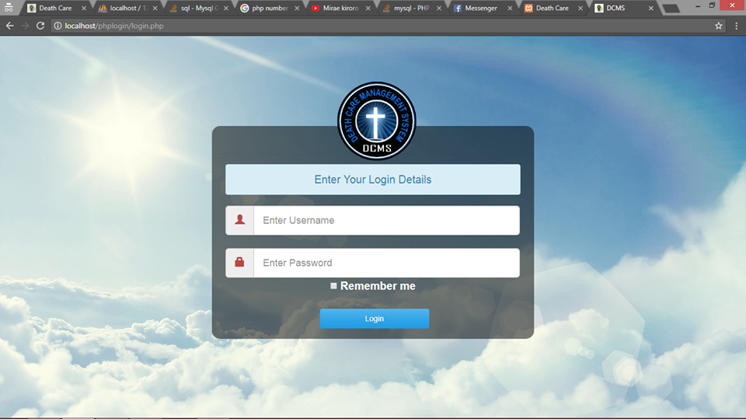

*Figure 20 Login*

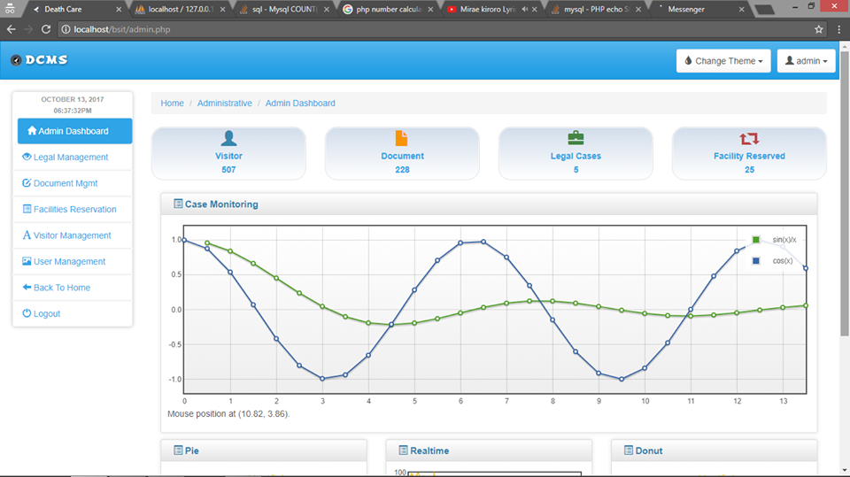

*Figure 21 Administrative Panel*

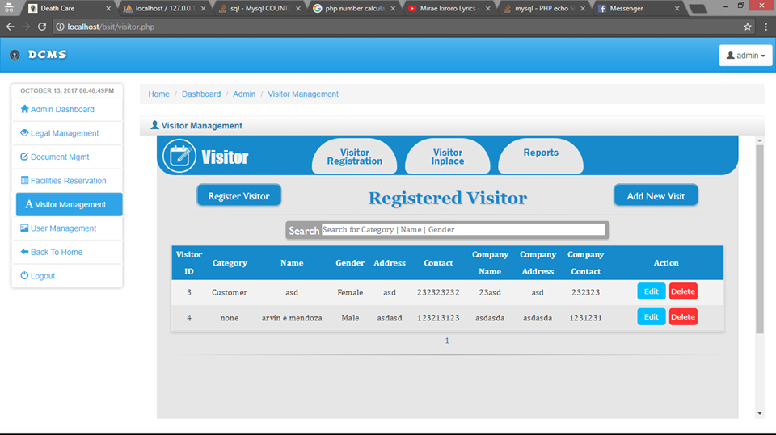

*Figure 22 Visitor Management Panel*

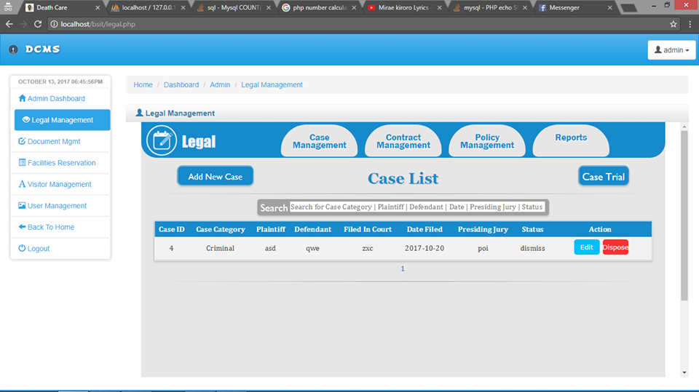

*Figure 23 Legal Management Panel*

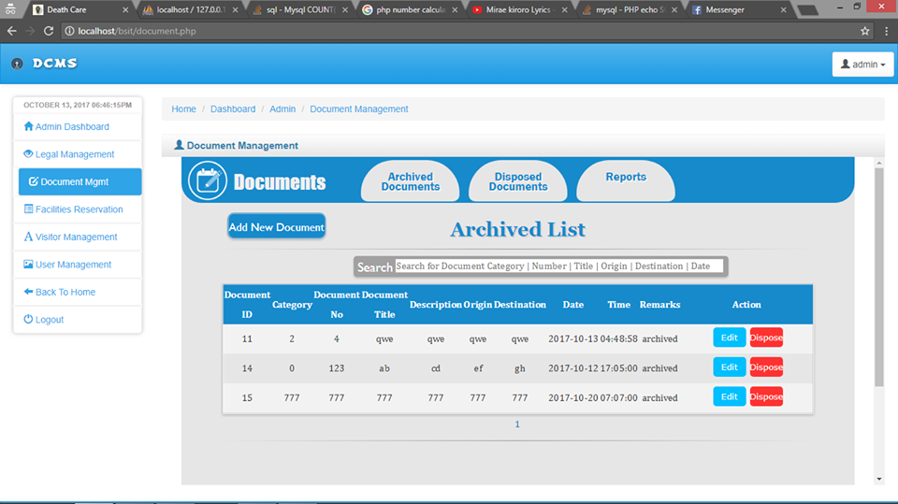

*Figure 24 Document Management Panel*

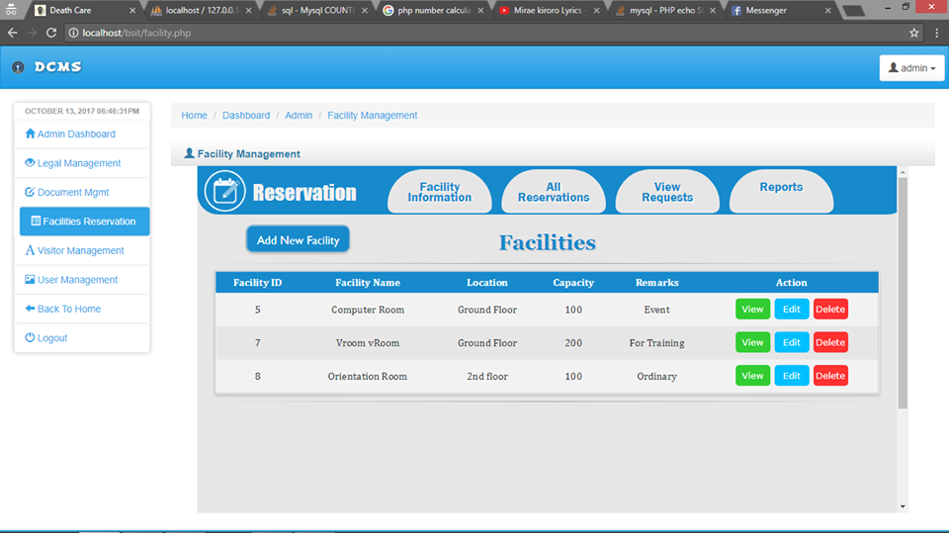

*Figure 25 Facilities Reservation Panel*

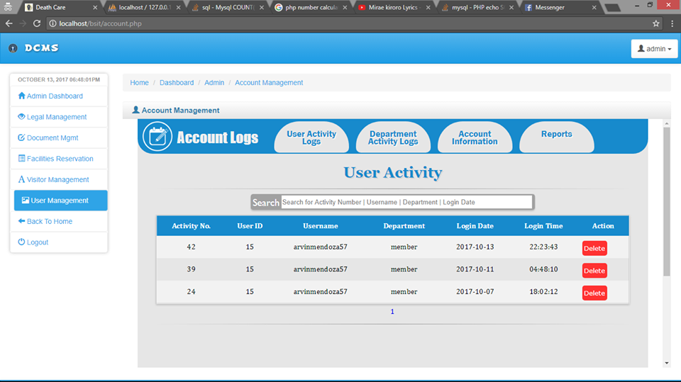

*Figure 26 User Management Panel*

3.5 Software Requirement Specification

3.5.1 Introduction

The system implemented by the Netbeans PHP as a front end and MySQL database for backend, to provide an accurate system that is needed a fully requirements to finish the system.

3.5.2 Goals and Objectives

The purpose of this document is to define requirements for the system named Administrative System that will function as a basis of the project. It is essential that an agreement of these requirements be reached so that expectations ca be achieved.

The more detailed goals of the Administrative System are as follows:

* To configure all the information about the Admin for a more suitable and useful system
* To have an automated process on management of documents, visitor, legal and facility reservations.
* To create a system that has features of having access for the admin and users.
* To give complete description for the overview and list of the requirement which meet the needs of the death care company.

3.5.3 System Statement Scope

This document covers the whole definitions of the Death Care Administrative System project. It basically includes the requirements for managing legal records, documents, visitor and facility reservations.

3.5.3.1 Major Constraints

There are several constraints that the Administrative System might undergo and these are as follows:

* Compatibility – the compatibility is one of the constraints about the problems in operating system with other computers, the proponents must know the capacity of the computer if it can run or handle the proposed system.
* Capability – the proponents must know the capability of a computer if it is can process without delays the functions of the proposed system.
* Integration – the proponents need to know and take time in gaining knowledge on how to integrate the modules and submodules of the proposed system.
* Time – the proponents have limited time to work on the development of the system.

3.5.3.1 General Requirements

The following general requirements were laid out for our project named Death Care Administrative System.

* Having a username and password to secure every details and information of every legal records, facility reservations, documents and visitors.
* User-friendly system
* Printable checklist of legal records, documents, facility reservations and visitor details as well as reports.
* Can add, edit, delete and save or can manipulate data.
* Can retrieve or search existing information or data.
* Can transfer information to other modules.
  + - 1. Business Requirements
* Add user or Client Information
* Update features
* Edit accounts or records
* Search records
* Generate reports
* View records
* Manage accounts
* View user log
  + - * 1. Define Business Requirements

The Business Requirements, provide a through description of what a new (or enhanced)product should do to meet the business objectives of the organization, the rationale behind the decision to develop the product, and the high-level factors that impact the ability of the organization to develop and deploy. Most often used to plan software development or other IT projects, the synthesis input from stakeholders and analysis of the current business situation to provide a technology-neutral description of what the product should do, rather than how it should do it. It includes data flow or process diagrams that illustrate how the current state, or as is, process occur, as well as high level diagrams that show how the future state will operate.

3.5.3.2.2 Business Area - A



*Figure 27 Business Area A*

3.5.3.2.3 Business Area - B



*Figure 28 Business Area B*

3.5.3.4 Business Process Flow



*Figure 29 Business Process Flow*

3.5.3.3 Functional Requirements

Process requirements describe what the application must do. Process requirements relate the entities and attributes from the data requirements to the users’ needs. State the functional process requirements in a manner that enables the reader to see broad concepts decomposed into layers of increasing detail.

3.5.3.3.1 Functional Purpose

 *Figure 30 Functional Purpose*

3.5.3.3.2 Use Case Diagram



*Figure 31 Use Case Diagram*

3.5.3.4 Data Management Requirements

* Rich Application - Multiple Data Resources
* Business Agility - Continuous Innovation
* Single View - Process Convergence
* Operational Insight - Real-Time
* Enterprise-Ready - Secure and Reliable

3.5.3.5 Archive/Purge Requirements

* Documents
* Blueprint of the System
  + - 1. Audit Requirements
* Printing of Documents
* Transportation
* Rentals
* Bills
  + - 1. Reporting Requirements
* Microsoft Word
* PowerPoint Presentation
* Audio Speaker
* Video Presentation

3.6 Systems Design Specification

3.6.1 Introduction

This chapter describes the design and architectural requirements and specifications in developing the Administrative System. This section provides the list of requirements and specifications against which to test the final project and determine whether the researchers of this software were able to successfully implement the system according to the design.

3.6.2 Goals and Objectives

The Administrative System attempts to make a better process than the existing system. The software is expected to be simple and having functions that can transact easier that the existing process.

3.6.3 Data Model Design

For the data design of the application, Netbeans 8.0.2 PHP IDE will apply for the front-end of the system. The development team used MySQL for the back-end for storing all data information in the form of tables. The proponents also used Xampp Apache Server as web server.

3.6.4 Process Model Design



*Figure 32 Process Model Design*

3.6.5 Create/Read/Update/Delete (CRUD) Matrix (Interaction Analysis)

|  |  |  |  |  |
| --- | --- | --- | --- | --- |
| Process | Create | Read | Update | Delete |
| Dashboard |  |  |  |  |
| Reports |  |  |  |  |
| File Case |  |  |  |  |
| Send Documents |  |  |  |  |
| View Case |  |  |  |  |
| Update File Case |  |  |  |  |
| Registration and Monitoring |  |  |  |  |
| Reservation Request |  |  |  |  |
| Add facility |  |  |  |  |
| Facility Description |  |  |  |  |
| File Storage |  |  |  |  |
| Archiving |  |  |  |  |

*Table 16 CRUD Matrix (Interaction Analysis)*

3.6.6 Technical Architecture

3.6.6.1 System Architecture



*Figure 33 System Architecture*

3.6.6.2 Object Mapping

PHP: Scripting Language

MySQL: Database

Photoshop: Photo Editor

Google: Image Provider

*Figure 34 Object Mapping*

3.6.6.3 Components Diagram

Data Store

User

Access

Denied

EXIT

Homepage

*Figure 35 Components Diagram*

* + - 1. Sequence Diagram

Input Username & PW

User

Login

Pick Module

Verified

Access Denied

Login History

Admin

*Figure 36 Sequence Diagram*

Chapter 4 Test Result and Discussion

Integration testing in the software testing model comes system testing and after the unit testing and after the unit has been done.

The way integration testing works is by, getting the individual modules that have been through the unit testing phase and integrating each module into a group, the integration testing phase will make sure when the modules are being integrated together that any problems, for example errors or bugs, cause due to the integration of the modules eliminated. Integration testing codes not deal with the integration of the whole system but deals with the integration of a process in the system.

In the integration testing stage there are three things are created, to ensure that the integration of the modules is successful and that it runs successful as well. A test plan, test cases and test data are produced to effectively test that the integration is successful. Test data is normally used by test cases as mentioned each type below.

4.1 Integration Test Plan

When producing a test plan it must include the following information to be effective.

* A strategy to use when testing the integrated modules and how the test will be conducted
* To know what the responsibility are of each integrated in our system.
* Get data from other integration
* Responsibilities
* Testing and pass condition
* Risk involved
* Database record

4.2 Integration Test Data

Test data is simply data that is used in order to test the actual program or the integrated modules. Test data would normally be used in a test case as this would be used to check the inputs and expected outputs.

The Proponents included an example of what test data is in the test case sample that was shown in the best section above.

4.3 Different Types of Integration Testing

The proponent needs to get data of the accounts/cases through other integration in the whole system. Below is a list of the different integration tests.

4.3.1 Database Testing

This is where the system gets the database information from the other integrated system. It was implemented by employee’s information. Since the system is about journalizing, we need to integrate from the other system. This is to get the accounts/cases of the required sub systems.

|  |  |  |
| --- | --- | --- |
| Login | | |
| Test Case | Test Scenario | Remarks |
| Username | The user will enter his or her username, registered in database | Successful |
| Password | The user will enter his or her the password, registered in database | Successful |
| Login | User click the log in button | Successful |
| Cancel | If the user clicked the cancel button the window will close | Successful |

*Table 17 Login Test Result*

4.3.2 Requirements Traceability Matrix

The requirements traceability matrix (RTM) reflects full user and system requirements for a system or part of the system. RTM captures all the requirements and their traceability in one document and the document must be submitted at the end of the life cycle.

RTM is used to record the relationship of requirements for the design, development, testing, and version of the software requirements for a specific version of the software. Changes to requirements are also recorded and tracked in the RTM. RTM is maintained throughout the life cycle of release and have been reviewed and resource data at the end of the release. It is very useful document to track time, change management and risk management in software development. The Requirements Traceability Matrix, which provides detailed idea about the importance of RTM in SDLC.

The table below displays the RTM for the conditions that have been approved to be included in Administrative System. The following information is provided for each:

|  |  |  |  |  |  |
| --- | --- | --- | --- | --- | --- |
| Test Number | Test Case  (Functionalities) | Result | | Remarks | Recommendation |
| Positive | Negative |
| 1 | Login |  |  | Successful | For Administrative Staff |
| 2 | Dashboard |  |  | Successful | For Administrative Staff |
| 3 | Add documents |  |  | Successful | For Administrative Staff |
| 4 | View documents |  |  | Successful | For Administrative Staff |
| 5 | Edit documents |  |  | Successful | For Administrative Staff |
| 6 | Delete documents |  |  | Successful | For Administrative Staff |
| 7 | Add disposal |  |  | Successful | For Administrative Staff |
| 8 | Manage Disposal |  |  | Successful | For Administrative Staff |
| 9 | Add New case |  |  | Successful | For Administrative Staff |
| 10 | Edit case |  |  | Successful | For Administrative Staff |
| 11 | Delete case |  |  | Successful | For Administrative Staff |
| 12 | Add new contract |  |  | Successful | For Administrative Staff |
| 13 | Edit contract |  |  | Successful | For Administrative Staff |
| 14 | Delete contract |  |  | Successful | For Administrative Staff |
| 15 | Add new policy |  |  | Successful | For Administrative Staff |
| 16 | Edit policy |  |  | Successful | For Administrative Staff |
| 17 | View requests |  |  | Successful | For Administrative Staff |
| 18 | Generate reports |  |  | Successful | For Administrative Staff |
| 19 | Add new facility |  |  | Successful | For Administrative Staff |
| 20 | Edit facility |  |  | Successful | For Administrative Staff |
| 21 | Delete facility |  |  | Successful | For Administrative Staff |
| 22 | View facility and description |  |  | Successful | For Administrative Staff |
| 23 | View reservations |  |  | Successful | For Administrative Staff |
| 24 | Add new reservations |  |  | Successful | For Administrative Staff |
| 25 | Edit reservations |  |  | Successful | For Administrative Staff |
| 26 | Generate reports |  |  | Successful | For Administrative Staff |
| 27 | Add new visitor |  |  | Successful | For Administrative Staff |
| 28 | Edit registered visitor |  |  | Successful | For Administrative Staff |
| 29 | Delete registered visitor |  |  | Successful | For Administrative Staff |
| 30 | View visitor in-place |  |  | Successful | For Administrative Staff |
| 31 | Generate reports |  |  | Successful | For Administrative Staff |
| 32 | Back to main menu |  |  | Successful | For Administrative Staff |
| 33 | Logout |  |  | Successful | For Administrative Staff |

*Table 18 Requirements Traceability Matrix*

Chapter 5 Appendices

Appendix A: Letter for interview signed by the interviewee and image

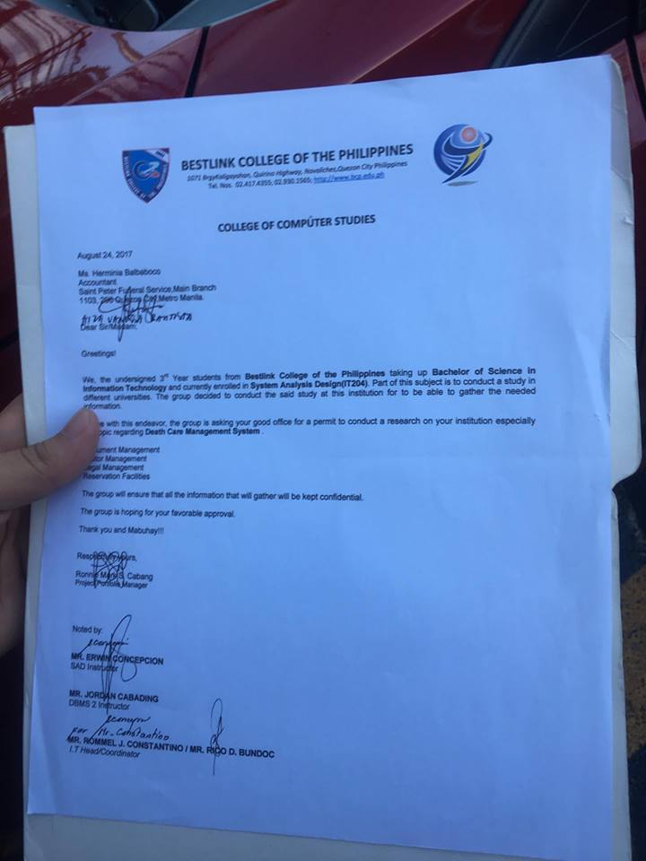

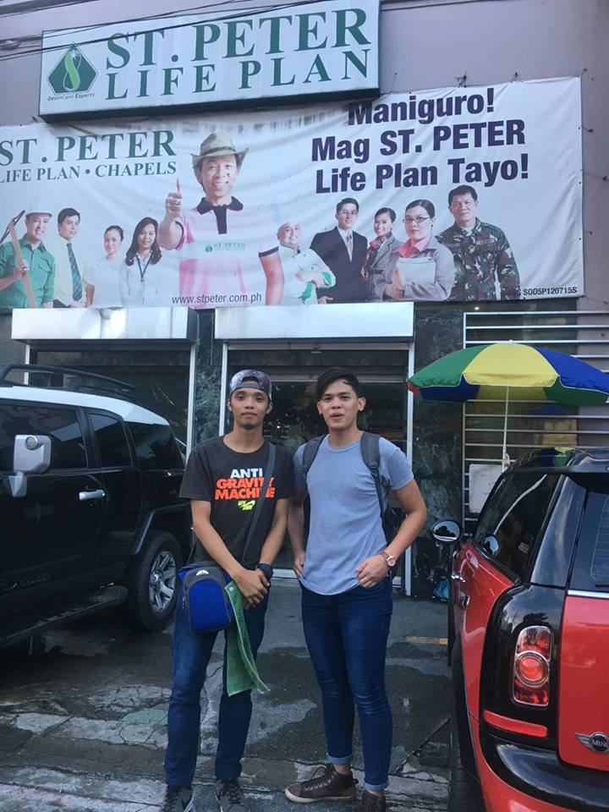

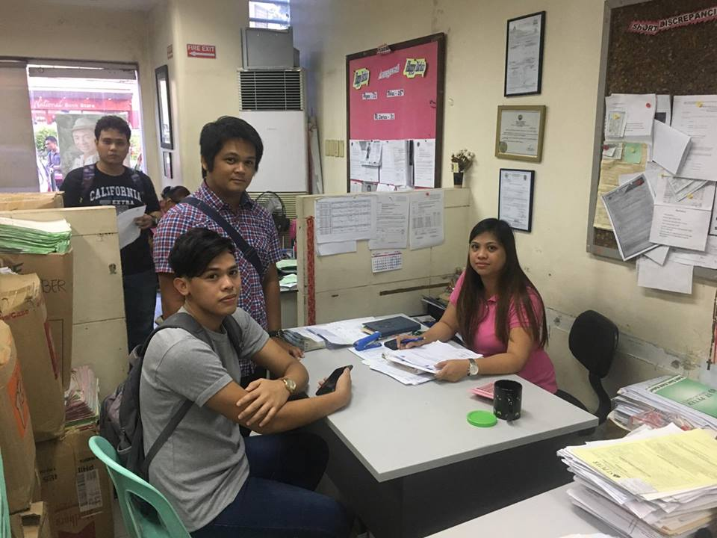

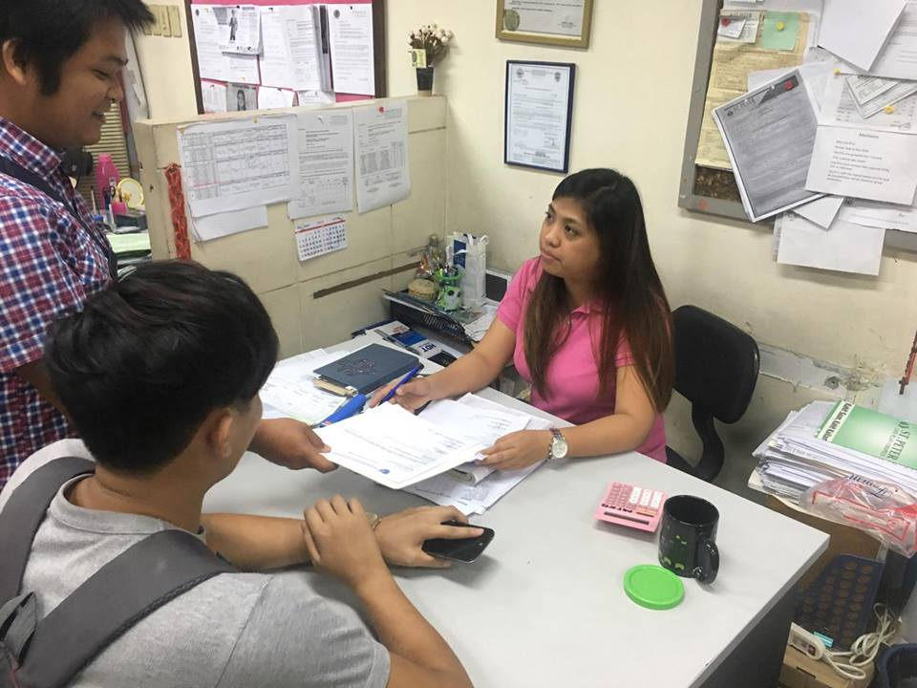

Appendix B: Supporting Documents

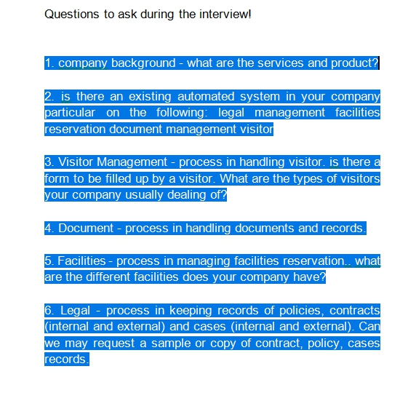

Appendix C: Code Listing

Website codes:

<?php

    include_once 'header.php';

?>

<script>

var slideIndex = 0;

showSlides();

function showSlides() {

    var i;

    var slides = document.getElementsByClassName("mySlides");

    var dots = document.getElementsByClassName("dot");

    for (i = 0; i < slides.length; i++) {

       slides[i].style.display = "none";

    }

    slideIndex++;

    if (slideIndex> slides.length) {slideIndex = 1}

    for (i = 0; i < dots.length; i++) {

        dots[i].className = dots[i].className.replace(" active", "");

    }

    slides[slideIndex-1].style.display = "block";

    dots[slideIndex-1].className += " active";

    setTimeout(showSlides, 3000); // Change image every 3 seconds

}

</script>

<div class="body1">

<div class="quicktab"><!--quicktab-->

        <div class="qtitle">

            <h2>Quick Tabs</h2>

        </div>

        <div class="qtab">

            Fill Up Our Survey<br>

                <div class="qtabdesc">

                    &#187; Customer Satisfactory Survey

                </div>

        </div>

        <div class="space"></div>

        <div class="qtab">

            Check Our Life Plans<br>

                <div class="qtabdesc">

                    &#187; Types | Features and Benefits

                </div>

        </div>

        <div class="space"></div>

        <div class="qtab">

            Online Burol Viewing<br>

                <div class="qtabdesc">

                    &#187; Online Viewing | E-Burol

                </div>

        </div>

        <div class="space"></div>

        <div class="qtab">

            E-Membership<br>

                <div class="qtabdesc">

                    &#187; Online Membership Payments

                </div>

        </div>

        <div class="space"></div>

        <div class="qtab">

            Heaven Addresses<br>

                <div class="qtabdesc">

                    &#187; Click Here To View

                </div>

        </div>

    </div><!--quicktab-->

</div><!--body1-->

<div class="body2">

    <div class="body2con">

        <div class="drop">

            <div class="condroparrow">

                &#187;

            </div><!--condroparrow-->

            <a href="lifeplan.php"><div class="condroptext">

                LifePlan

            </div><!--condroptext--></a>

                <div class="dropoverlay">

                    <ul>

                        <a href="lifeplan.php"><li>&#8250; Life Plans</li></a>

                        <a href="officers.php"><li>&#8250; Officers</li></a>

                        <a href="cremation.php"><li>&#8250; Cremation Plans</li></a>

                        <a href="faq.php"><li>&#8250; FAQ</li></a>

                        <a href="officers.php"><li>&#8250; Offices</li></a>

                    </ul>

                </div><!--dropoverlay#1-->

        </div><!--drop#1-->

        <div class="body2conpic">

            <a href="news.php"><img src="images/bcp.jpg" class="stretch"></a>

        </div><!--body2conpic-->

        <div class="body2context">

            <a href="news.php"><h4>Bestlink College of the Philippines now officially a partner of DeathCare!</h4></a>

            <p>Due to continuous growth, BSIT-3201 DeathCare established a partnership with Bestlink College of the Philippines, Students recieves free lifeplans.</p>

        </div><!--body2context-->

    </div><!--bodycon2#1-->

    <div class="body2con">

        <div class="drop">

            <div class="condroparrow">

                &#187;

            </div><!--condroparrow-->

            <a href="chapels.php"><div class="condroptext">

                Chapels

            </div><!--condroptext--></a>

                <div class="dropoverlay">

                    <ul>

                        <a href="chapels.php"><li>&#8250; Facilities & Amenities</li></a>

                        <a href="caskets.php"><li>&#8250; Caskets</li></a>

                        <a href="crematoriums.php"><li>&#8250; Crematoriums</li></a>

                        <a href="vas.php"><li>&#8250; Value Added Services</li></a>

                        <a href="csr.php"><li>&#8250; CSR Programs</li></a>

                    </ul>

                </div><!--dropoverlay#2-->

        </div><!--drop#2-->

        <div class="body2conpic">

            <a href="news.php"><img src="images/bcp1.png" class="stretch"></a>

        </div><!--body2conpic-->

        <div class="body2context">

            <a href="news.php"><h4>SENIOR CITIZENS AND PERSON WITH DISABILITY 20% OFF DISCOUNT </h4></a>

            <p>Learn more about the Senior Citizen and Person with disability (PWD) 20% OFF DISCOUNT promo mechanics!</p>

        </div><!--body2context-->

    </div><!--bodycon2#2-->

    <div class="body2con">

        <div class="drop">

            <div class="condroparrow">

                &#187;

            </div><!--condroparrow-->

            <a href="about.php"><div class="condroptext">

                About Us

            </div><!--condroptext--></a>

                <div class="dropoverlay">

                    <ul>

                        <a href="about.php"><li>&#8250; Death Care</li></a>

                        <a href="history.php"><li>&#8250; History</li></a>

                        <a href="vmv.php"><li>&#8250; Vision & Mission</li></a>

                        <a href="modules.php"><li>&#8250; Modules</li></a>

                        <a href="news.php"><li>&#8250; News & Updates</li></a>

                    </ul>

                </div><!--dropoverlay#3-->

        </div><!--drop#3-->

        <div class="body2conpic">

            <a href="news.php"><img src="images/bcp2.jpg" class="stretch"></a>

        </div><!--body2conpic-->

        <div class="body2context">

            <a href="news.php"><h4>BSIT-3201 created a NEW DeathCare system and will now be integrated!</h4></a>

            <p>BCP's BS Information Technology 3rd year 2nd semester Section 1(One) created a new way of processing data and information. </p>

        </div><!--body2context-->

    </div><!--bodycon2#3-->

</div><!--body2-->

<br>

<br>

<br>

<br>

<br>

<br>

<br>

<br>

<br>

<br>

<br>

<br>

<?php

    include_once 'footer.php';

?>

Document Save

<?php

if (isset($_POST['submit'])) {

$dbServername = "localhost";

$dbUsername = "root";

$dbPassword = "";

$dbName = "loginsystem";

$conn = mysqli_connect($dbServername, $dbUsername, $dbPassword, $dbName);

    $cat = mysqli_real_escape_string($conn, $_POST['d_category']);

    $no = mysqli_real_escape_string($conn, $_POST['d_no']);

    $title = mysqli_real_escape_string($conn, $_POST['d_title']);

    $desc = mysqli_real_escape_string($conn, $_POST['description']);

    $origin = mysqli_real_escape_string($conn, $_POST['origin']);

    $des = mysqli_real_escape_string($conn, $_POST['destination']);

    $date = mysqli_real_escape_string($conn, $_POST['date']);

    $time = mysqli_real_escape_string($conn, $_POST['time']);

                    $sql = "INSERT INTO documents (d_category, d_no, d_title, description, origin,

                    destination, date, time, remarks)

                    VALUES ('$cat', '$no', '$title', '$desc', '$origin', '$des', '$date', '$time', 'archived');";

                    mysqli_query($conn, $sql);

                    header("Location: ../documentlist.php?Visit=success");

                    exit();

} else {

    header("Location: ../documentlist.php");

    exit();

}

Legal Edit

<?php

include 'includes/connect.php';

if(isset($_POST['submit'])){

    $sql = "update legalcase set c_type = '".$_POST['c_type']."',

                                    plaintiff = '".$_POST['plaintiff']."',

                                    defendant = '".$_POST['defendant']."',

                                    fic = '".$_POST['fic']."',

                                    date = '".$_POST['date']."',

                                    p_jury = '".$_POST['p_jury']."'

            where c_id = '".$_POST['c_id']."'

    ";

    if(mysqli_query($conn, $sql)){

        header('Location:case.php');

    }else{

        echo "Error".mysqli_error($conn);

    }

}

if(isset($_POST['cancel'])){

    header('Location:case.php');

}

$cid = '';

$ctype = '';

$plaintiff = '';

$defendant = '';

$fic = '';

$date = '';

$jury = '';

if(isset($_GET['c_id'])){

    $sql = "select * from legalcase

    where c_id=".$_GET['c_id'];

    $result = mysqli_query($conn, $sql);

    if(mysqli_num_rows($result) > 0){

        $row = mysqli_fetch_assoc($result);

        $cid = $row['c_id'];

        $ctype = $row['c_type'];

        $plaintiff = $row['plaintiff'];

        $defendant = $row['defendant'];

        $fic = $row['fic'];

        $date = $row['date'];

        $jury = $row['p_jury'];

    }

}

?>

<!DOCTYPE html>

<html lang="en">

<head>

    <meta charset="UTF-8">

    <meta name="viewport" content="width=device-width, initial-scale=1.0">

    <meta http-equiv="X-UA-Compatible" content="ie=edge">

    <link rel="stylesheet" type="text/css" href="legal.css">

    <link rel="stylesheet" type="text/css" href="css/bootstrap.css">

    <link rel="stylesheet" type="text/css" href="css/bootstrap.min.css">

    <script src="jquery.js"></script>

    <script src="js/bootstrap.js"></script>

    <title></title>

<script language="JavaScript" type="text/javascript">

    function checkDelete(){

    return confirm('Are you sure?');

}

</script>

</head>

<body>

    <div class="wrapper">

        <div class="header">

            <div class="logo"><img src="images/res.png" width="60" height="60"><p>Legal</p></div>

            <a href="case.php"><div class="tab"><p>Case<br>Management</p></div></a>

            <a href="contractlist.php"><div class="tab"><p>Contract<br>Management</p></div></a>

            <a href="policy.php"><div class="tab"><p>Policy<br>Management</p></div></a>

        </div><!--header-->

        <div class="body">

            <div class="title"><b>Modify Case Info</b></div><br><br><br>

            <div class="three">

    <div class="centralform">

                <form method="POST" action="" name="vform" class="form-horizontal" align="justify">

                <p><b>Recent Category Value: </b><?=$ctype?><br></p>

                <b>Case Category: </b><br>

                <select name="c_type">

                        <option value="none">==Select Category==</option>

                        <option value="Administrative">Administrative</option>

                        <option value="Criminal">Criminal</option>

                        <option value="Civil">Civil</option>

                                </select><br><br>

                <b>Plaintiff: </b><br>

                <input type="text" name="plaintiff" maxlength="20" value="<?=$plaintiff?>"/><br><br>

                <b>Defendant: </b><br>

                <input type="text" name="defendant" maxlength="20" value="<?=$defendant?>"/><br><br>

                <b>Filed in Court: </b><br>

                <input type="text" name="fic" maxlength="20" value="<?=$fic?>"/><br><br>

                <b>Date Filed: </b><br>

                <input name="date" id="date" type="date" min="2017-01-01" onkeydown="return false" value="<?=$date?>"/><br><br>

                <b>Presiding Jury: </b><br>

                <input type="text" name="p_jury" maxlength="20" value="<?=$jury?>"/><br><br>

            <input type="hidden" name="c_id" value="<?=$cid?>">

            <button type="submit" name="submit">Submit</button>

            <button type="submit" name="cancel">Cancel</button>

            </div><br><br>

</form>

            </div><!--one-->

        </div><!--body-->

    </div><!--wrapper-->

    <!--datescript-->

<script type="text/javascript">

//disable past dates

    var today = new Date().toISOString().split('T')[0];

    document.getElementsByName("date")[0].setAttribute('min', today);

</script>

<!--datescript-->

<script type="text/javascript">

//check if date is empty

    var valueDate = document.getElementById('date').value;

if ( valueDate== null || valueDate== '')

{

    alert('Date is empty');

    return false;

}

</script>

</body>

</html>

Facility Delete

<?php

include 'connect.php';

if(isset($_GET['f_id'])){

    $sql = "delete from facility where f_id=".$_GET['f_id'];

    if(mysqli_query($conn, $sql)){

        header('Location: ../facilities.php');

    }else{

        echo "Error".mysqli_error($conn);

    }

}

Visitor Report

<?php

    include 'includes/connect.php';

    error_reporting(0);

?>

<!DOCTYPE html>

<html lang="en">

<head>

    <meta charset="UTF-8">

    <meta name="viewport" content="width=device-width, initial-scale=1.0">

    <meta http-equiv="X-UA-Compatible" content="ie=edge">

    <link rel="stylesheet" type="text/css" href="report.css">

    <link rel="stylesheet" type="text/css" href="css/bootstrap.css">

    <link rel="stylesheet" type="text/css" href="css/bootstrap.min.css">

    <script src="jquery.js"></script>

    <script src="js/bootstrap.js"></script>

    <title></title>

</head>

<body>

<div class="wrapper">

        <div class="header">

            <div class="logo"><img src="images/res.png" width="60" height="60"><p>Visitor</p></div>

            <a href="visitlist.php"><div class="tab"><p>Visitor<br>Registration</p></div></a>

            <a href="ovlist.php"><div class="tab"><p>Visitor<br>Inplace</p></div></a>

            <a href="reports.php"><div class="tab"><p>Reports</p></div></a>

        </div><!--header-->

        <div class="body">

            <div id="four">

                <div id="fourtab">

                    <div id="fetab">

<form method="POST" action="" onsubmit="return Validate()" name="vform">

                        <b>Select Report:</b> <br>

                        <select name="report">

                        <option value="none">==Report Type==</option>

                        <option value="reg">Visitor Registration</option>

                        <option value="his">Visit History</option>

                                </select><br><br>

                        <b>Start Date:</b><br>

                        <input type="date" name="startdate" id="disabled_input"/><br>

                        <b>End Date:</b><br>

                        <input type="date" name="enddate" id="disabled_input1"/><br><br>

                        <b>Order By:</b> <br>

                        <select name="orderby" id="disabled_input2">

                        <option value="none">==Order By==</option>

                        <option value="vtrack_id">Track ID</option>

                        <option value="date">Date</option>

                                </select><br>

                        <select name="orderlist">

                        <option value="ASC">Ascending</option>

                        <option value="DESC">Descending</option>

                                </select><br><br>

                        <button type="submit" name="submit" class="btn btn-primary">Go</button>

</form>

                    </div><!--fetab-->

                </div><!--fourtab-->

                <div id="tabfourcont">

<?php

$report = '';

$startdate = '';

$enddate = '';

$orderby = '';

$list = '';

if (isset($_POST['submit'])) {

    $report = $_POST['report'];

    $startdate = $_POST['startdate'];

    $enddate = $_POST['enddate'];

    $orderby = $_POST['orderby'];

    $list = $_POST['orderlist'];

            if ($report == 'his'){

    $report = $_POST['report'];

    $startdate = $_POST['startdate'];

    $enddate = $_POST['enddate'];

    $orderby = $_POST['orderby'];

    $list = $_POST['orderlist'];

        $sql = "SELECT * from visitor_tracking where t_out is not null AND date BETWEEN '$startdate' AND '$enddate' ORDER BY $orderby $list";

        $result = mysqli_query($conn, $sql);

        if(mysqli_num_rows($result) > 0){

            ?>

            <div class="headerx">

        <div class="logox"><img src="img/logo1.png" class="stretch"></div>

        <div class="logotextx">

            <h2>Death Care</h2><br>

            <p>BSIT Death Care Services</p>

            <p>Bestlink College of the Philippines</p>

            <p>915 Quirino Highway, Novaliches, Quezon City</p>

            <p>(02) 937-1032</p>

        </div><!--logotext-->

        <div class="logox"><img src="img/logo2.png" class="stretch"></div>

    </div><!--header--><br>

             <div class="table.responsive" style="margin: 0 auto;">

            <table style="box-shadow: none;" align="center">

                <h3>Visit Report</h3>

            <tr>

        <td class="td"><b>Visitor<br>Track ID</b></td>

        <td class="td"><b>Visitor<br>ID</b></td>

        <td class="td"><b>Date</b></td>

        <td class="td"><b>Time-In</b></td>

        <td class="td"><b>Time-Out</b></td>

        <td class="td"><b>Person<br>to Visit</b></td>

        <td class="td"><b>Department</b></td>

        <td class="td"><b>Purpose<br>of Visit</b></td>

        <td class="td"><b>Tag No.</b></td>

        <td class="td"><b>Remarks</b></td>

    </tr>

            <?php

            while($row = mysqli_fetch_array($result)){

                ?>

                <tr>

            <td><?=$row['vtrack_id']?></td>

            <td><?=$row['v_id']?></td>

            <td><?=$row['date']?></td>

            <td><?=$row['t_in']?></td>

            <td><?=$row['t_out']?></td>

            <td><?=$row['persontovisit']?></td>

            <td><?=$row['department']?></td>

            <td><?=$row['purpose']?></td>

            <td><?=$row['tag']?></td>

            <td><?=$row['remarks']?></td>

        </tr>

                <?php

            }

            ?>

            <button id="printPageButton" onclick="myFunction()" class="printpage">Print</button>

            <?php

        }

        else{

            echo '<div class="notfound">Data not found.</div>';

        }

}elseif ($report == 'reg'){

        $sql = "select v_id, category, CONCAT(v_first, ' ', v_middle, ' ', v_last) AS name,

        Gender, address, contact, company_name, company_address, company_contact from visitors ORDER BY v_id $list";

        $result = mysqli_query($conn, $sql);

        if(mysqli_num_rows($result) > 0){

            ?>

            <div class="headerx">

        <div class="logox"><img src="img/logo1.png" class="stretch"></div>

        <div class="logotextx">

            <h2>Death Care</h2><br>

            <p>BSIT Death Care Services</p>

            <p>Bestlink College of the Philippines</p>

            <p>915 Quirino Highway, Novaliches, Quezon City</p>

            <p>(02) 937-1032</p>

        </div><!--logotext-->

        <div class="logox"><img src="img/logo2.png" class="stretch"></div>

    </div><!--header--><br>

             <div class="table.responsive" style="margin: 0 auto;">

            <table style="box-shadow: none;" align="center">

                <h3>Visitor Report</h3>

            <tr>

        <td class="td"><b>Visitor<br>ID</b></td>

        <td class="td"><b>Category</b></td>

        <td class="td"><b>Name</b></td>

        <td class="td"><b>Gender</b></td>

        <td class="td"><b>Address</b></td>

        <td class="td"><b>Contact</b></td>

        <td class="td"><b>Company<br>Name</b></td>

        <td class="td"><b>Company<br>Address</b></td>

        <td class="td"><b>Company<br>Contact</b></td>

    </tr>

            <?php

            while($row = mysqli_fetch_array($result)){

                ?>

                <tr>

            <td><?=$row['v_id']?></td>

            <td><?=$row['category']?></td>

            <td><?=$row['name']?></td>

            <td><?=$row['Gender']?></td>

            <td><?=$row['address']?></td>

            <td><?=$row['contact']?></td>

            <td><?=$row['company_name']?></td>

            <td><?=$row['company_address']?></td>

            <td><?=$row['company_contact']?></td>

        </tr>

                <?php

            }

            ?>

            <button id="printPageButton" onclick="myFunction()" class="printpage">Print</button>

            <?php

        }

        else{

            echo '<div class="notfound">Data not found.</div>';

        }

}else{

    echo '<div class="notfound">Data not found.</div>';

}

}

?>

<br>

                </div><!--fourtab-->

            </div>

        </div><!--body-->

<!--wrapper-->

</body>

</html>

<script>

function myFunction() {

    window.print();

}

</script>

<script>

    $(document).ready(function() {

    $('#disabled_input').attr('disabled','disabled');

    $('select[name="report"]').on('change',function(){

    var  others = $(this).val();

        if(others == "his"){

        $('#disabled_input').removeAttr('disabled');

         }else{

         $('#disabled_input').attr('disabled','disabled');

        }

      });

    });

</script>

<script>

    $(document).ready(function() {

    $('#disabled_input1').attr('disabled','disabled');

    $('select[name="report"]').on('change',function(){

    var  others = $(this).val();

        if(others == "his"){

        $('#disabled_input1').removeAttr('disabled');

         }else{

         $('#disabled_input1').attr('disabled','disabled');

        }

      });

    });

</script>

<script>

    $(document).ready(function() {

    $('#disabled_input2').attr('disabled','disabled');

    $('select[name="report"]').on('change',function(){

    var  others = $(this).val();

        if(others == "his"){

        $('#disabled_input2').removeAttr('disabled');

         }else{

         $('#disabled_input2').attr('disabled','disabled');

        }

      });

    });

</script>

Connection to Database

<?php

$dbServername = "localhost";

$dbUsername = "root";

$dbPassword = "";

$dbName = "loginsystem";

$conn = mysqli_connect($dbServername, $dbUsername, $dbPassword, $dbName);

Appendix D: List of Acronyms

DCMS - Death Care Management System

DMS - Document Management System

LMS - Legal Management System

FR - Facilities Reservation

VMS - Visitor Management System

SDLC - System Development Life Cycle

HTML - Hypertext Markup Language

CSS - Cascading Style Sheets

PHP - Hypertext Preprocessor

RAM - Random Access Memory

DFD - Data Flow Diagram

WBS - Work Breakdown Structure

EIS - Enterprise Integrated System

RTM - Requirements Traceability Matrix

SRS - Software Requirements Specification

SDS - Systems Design Specification

SQL - Structured Query Language

DMD - Data Model Design

PM - Project Manager

BA - Business Analyst

SA - Systems Analyst

DS - Document Specialist

LP - Lead Programmer

Appendix E: List of Tables

Table 1 Project Deliverable 1

Table 2 Project Deliverable 2

Table 3 Project Deliverable 3

Table 4 Project Deliverable 4

Table 5 Project Deliverable 5

Table 6 Project Timeline

Table 7 Risk Management Plan

Table 8 Technical Features (Software)

Table 9 Technical Features (Hardware)

Table 10 Project Organization and Staffing

Table 11 Project Budget

Table 12 Document Management Matrix

Table 13 Legal Management Matrix

Table 14 Facility Reservation Matrix

Table 15 Visitor Management Matrix

Table 16 CRUD Matrix (Interaction Analysis)

Table 17 Login Test Result

Table 18 Requirements Traceability Matrix

Appendix F: List of Figures

Figure 1 Waterfall Model

Figure 2. Archive One Document Management System Philippines

Figure 3 Paperless Trail Archive One

Figure 4 IBM Philippine Legal Management System

Figure 5 Case Master Pro

Figure 6 Skedda (Melbourne Australia)

Figure 7 ActiveNet (Dallas, Texas)

**Figure 8** E.VIS Visitor Management System

Figure 9 ePLDT EVE – Enhanced Visitor Experience

Figure 10 HyperSoft: Automated Hypertext Support for Software Maintenance

Figure 11 Kofax Perceptive Document Management

Figure 12 ClioCloud

Figure 13 CaseFox.com

Figure 14 Diamond Hotel Philippines

Figure 15 Aim Conference Center (Makati)

Figure 16 Jolly Tech Visitors Management System

Figure 17 AC2000 WEB Visitor Management

Figure 18 Data Flow Diagram

Figure 19 Work Breakdown Structure

Figure 20 Login

Figure 21 Administrative Panel

Figure 22 Visitor Management Panel

Figure 23 Legal Management Panel

Figure 24 Document Management Panel

Figure 25 Facilities Reservation Panel

Figure 26 User Management Panel

Figure 27 Business Area A

Figure 28 Business Area B

Figure 29 Business Process Flow

Figure 30 Functional Purpose

Figure 31 Use Case Diagram

Figure 32 Process Model Design

Figure 33 System Architecture

Figure 34 Object Mapping

Figure 35 Components Diagram

Figure 36 Sequence Diagram